Mini User Manual for ClassPlus_Sprint3

1. Start Server

a. Download and unzip the Sprint3_Group4.zip

b. In your terminal, go to the folder ClassPlus and run

node server.js

c. go to the link at localhost:3000



2. Login

a. Here is the main page when you go to the localhost:3000



b. You can click any button to go to the login page. (Every page is allow only for the user)

c. Since you are a new user, do not have an account, you can click the Sign Up button under the Login button.

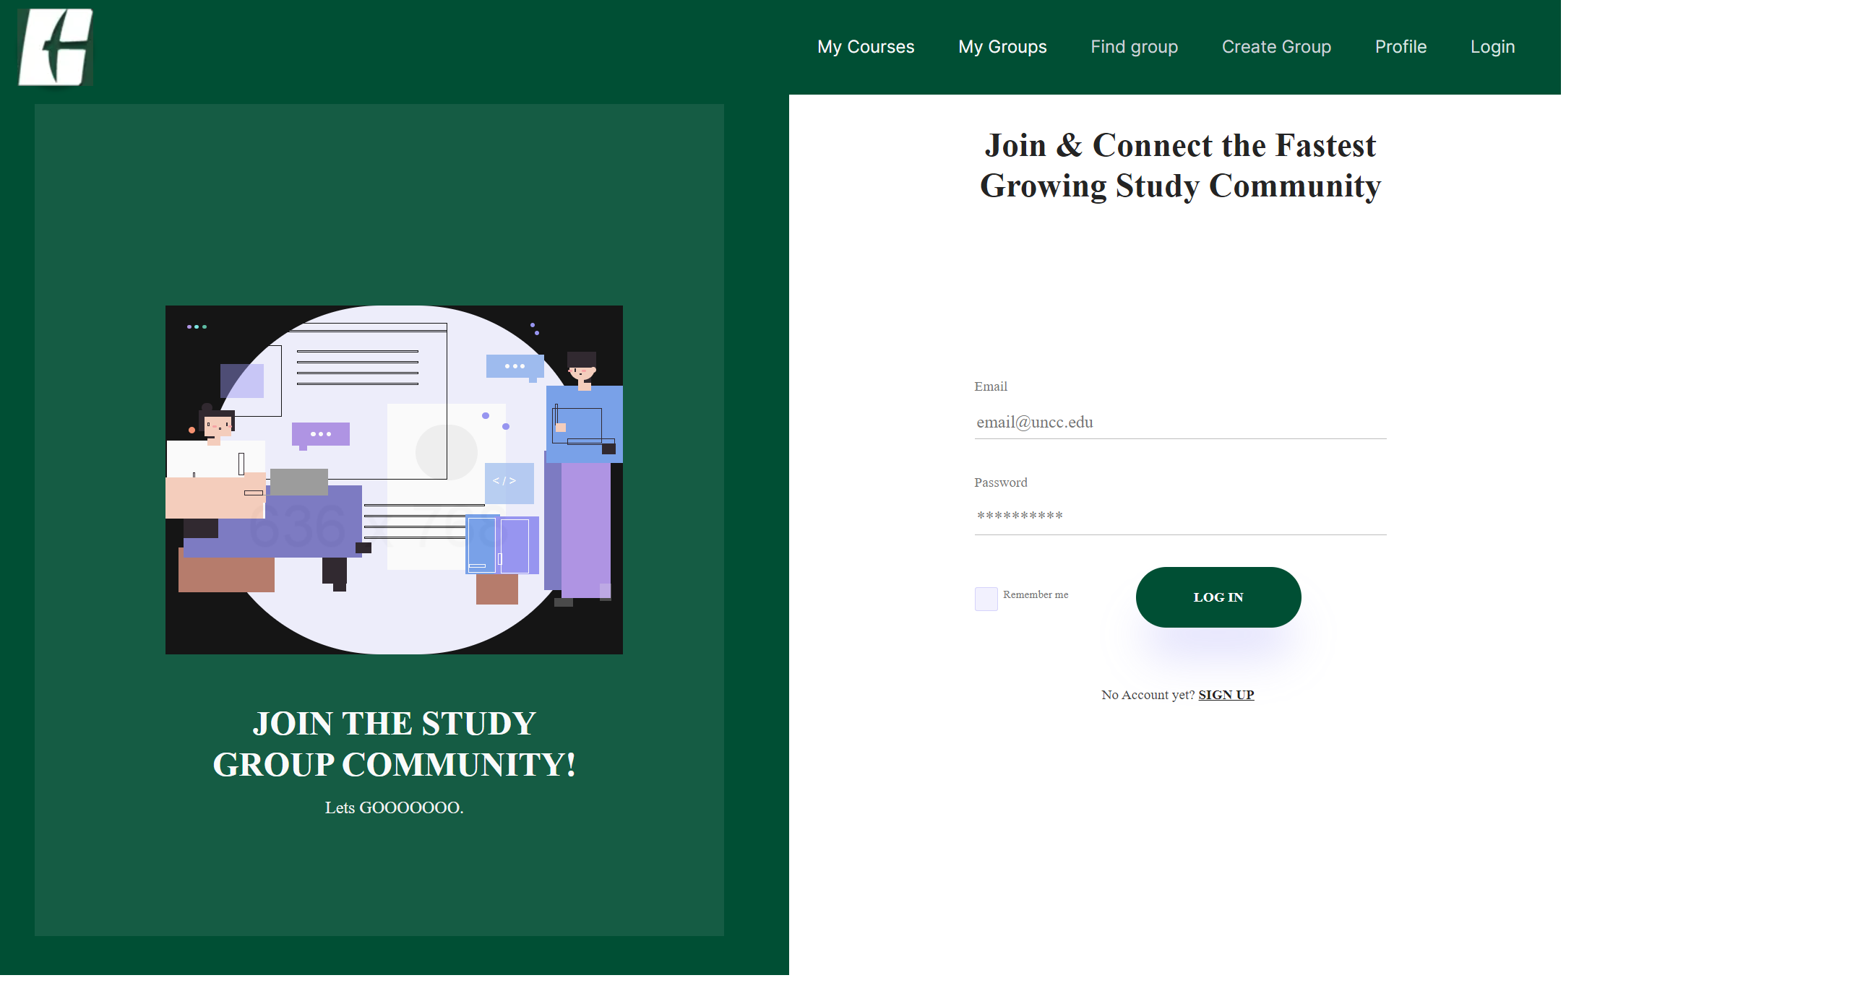

d. You can only use UNCC email to sign up for ClassPlus.

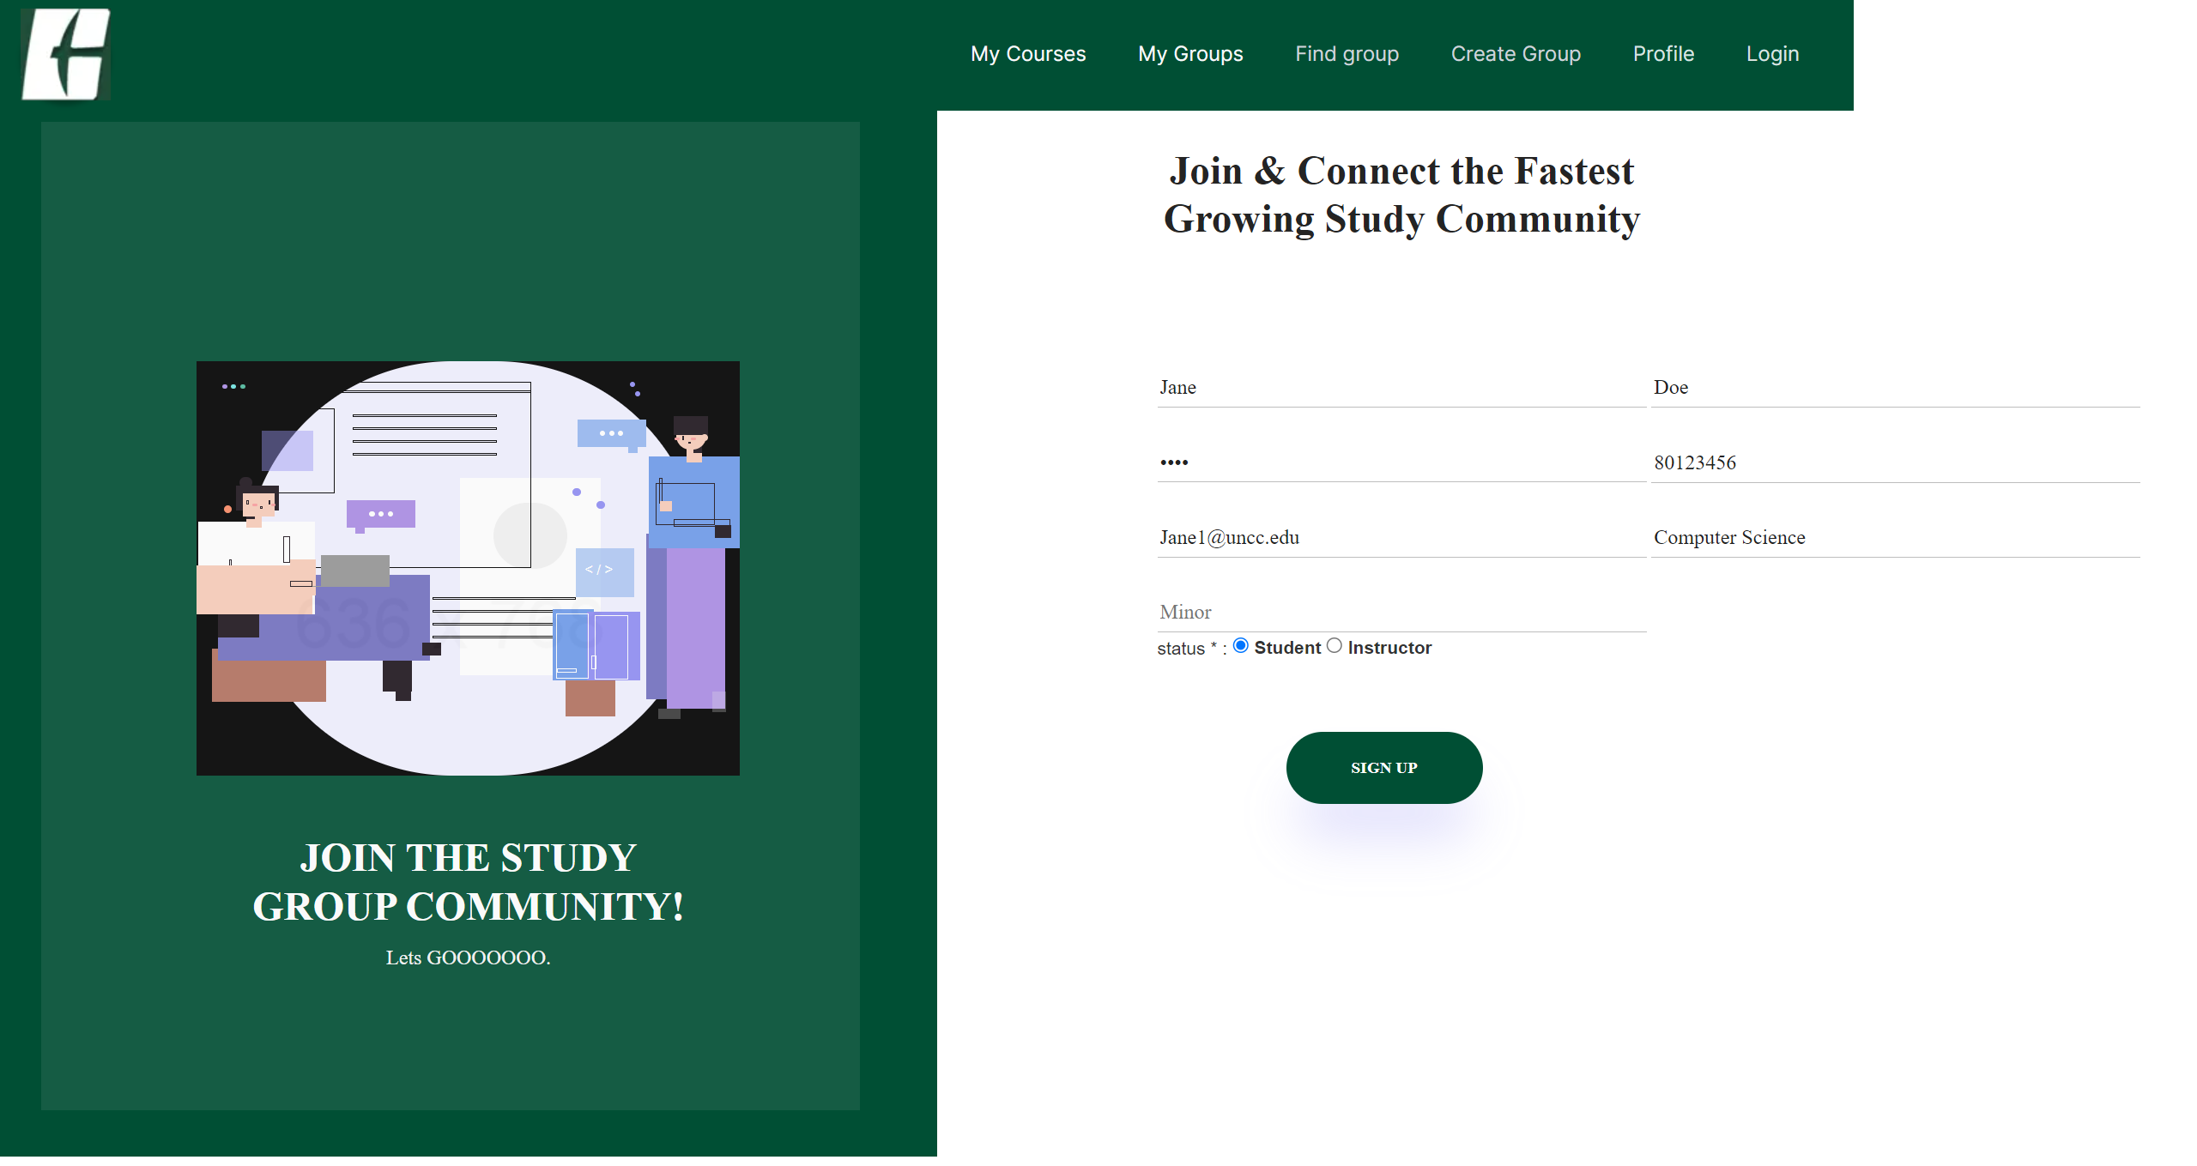

e. Once you click the Sign Up button, it will navigate you to the login page. You can use your UNCC email and password that you used for signing up.

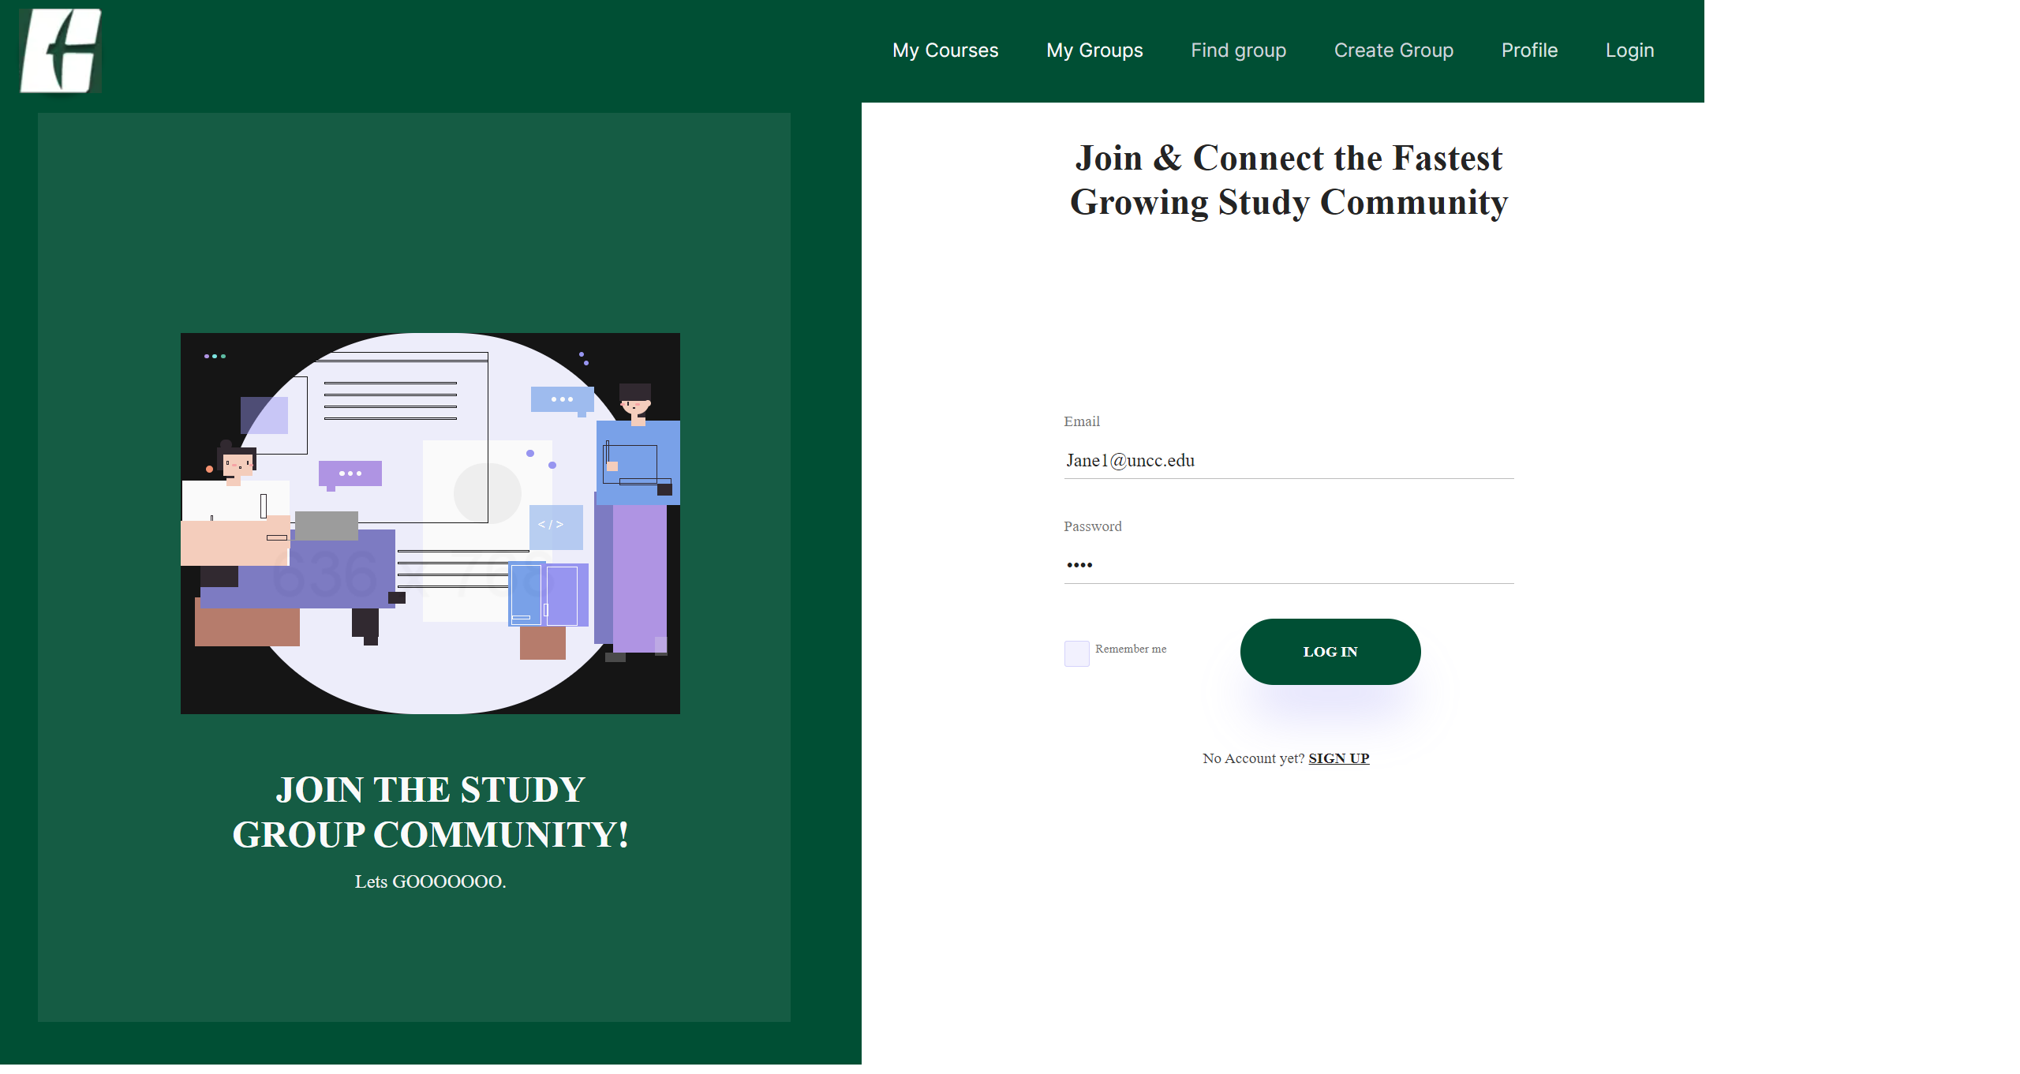

f. Now you are logged in to the ClassPlus website.

* You can also log out by clicking the Logout button on the menu bar.

3. Profile Page

a. To see and edit your profile, you can click the profile button on the menu bar.



b. You can see your profile information here, and change your profile and your profile picture by clicking the save button.

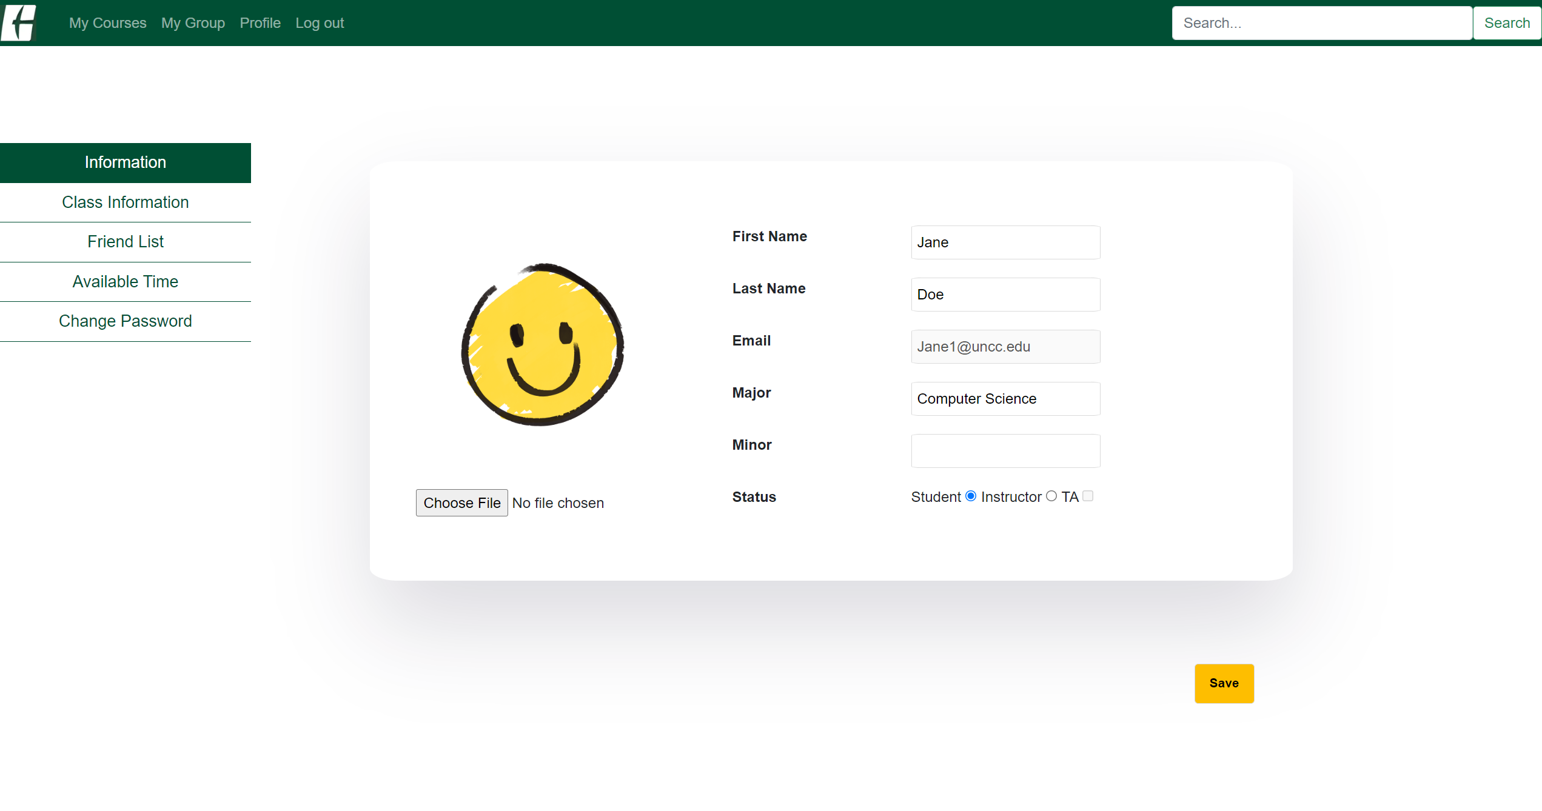

c. You can also see other information such as Class you enrolled and Friend List.

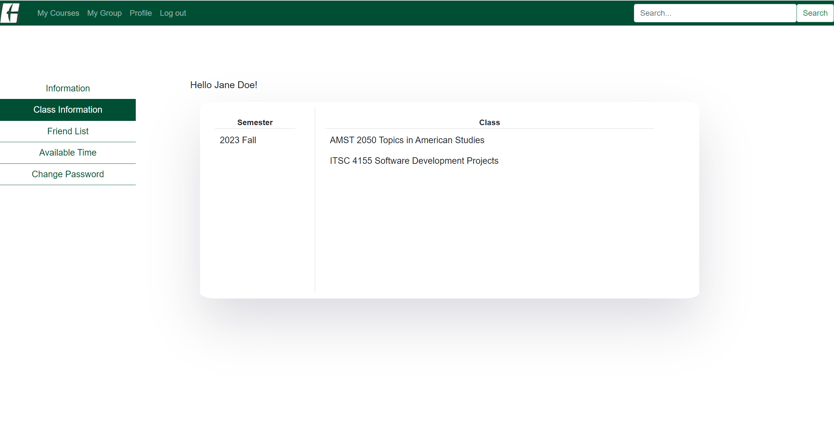

*You can go to the course page by clicking the course name.

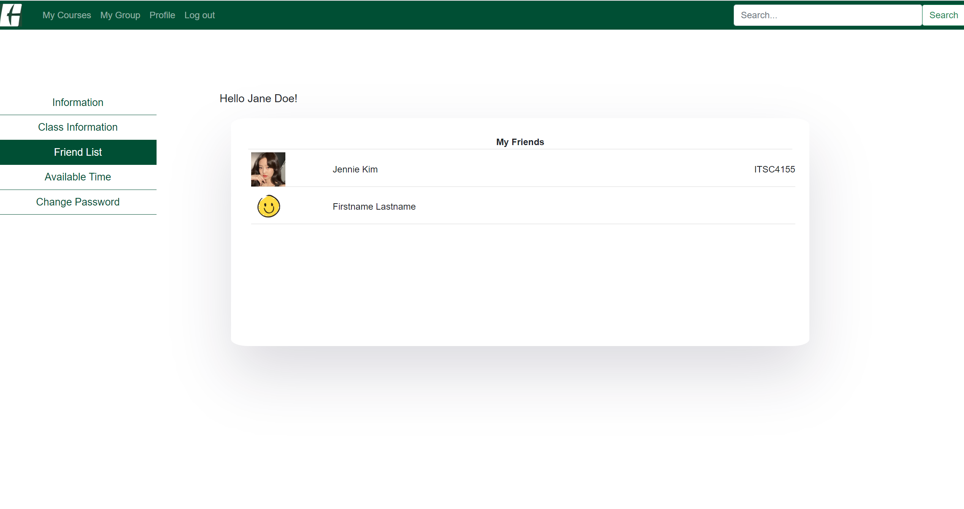

* On the right side of the friend's name, it shows which classes I have with my friend.

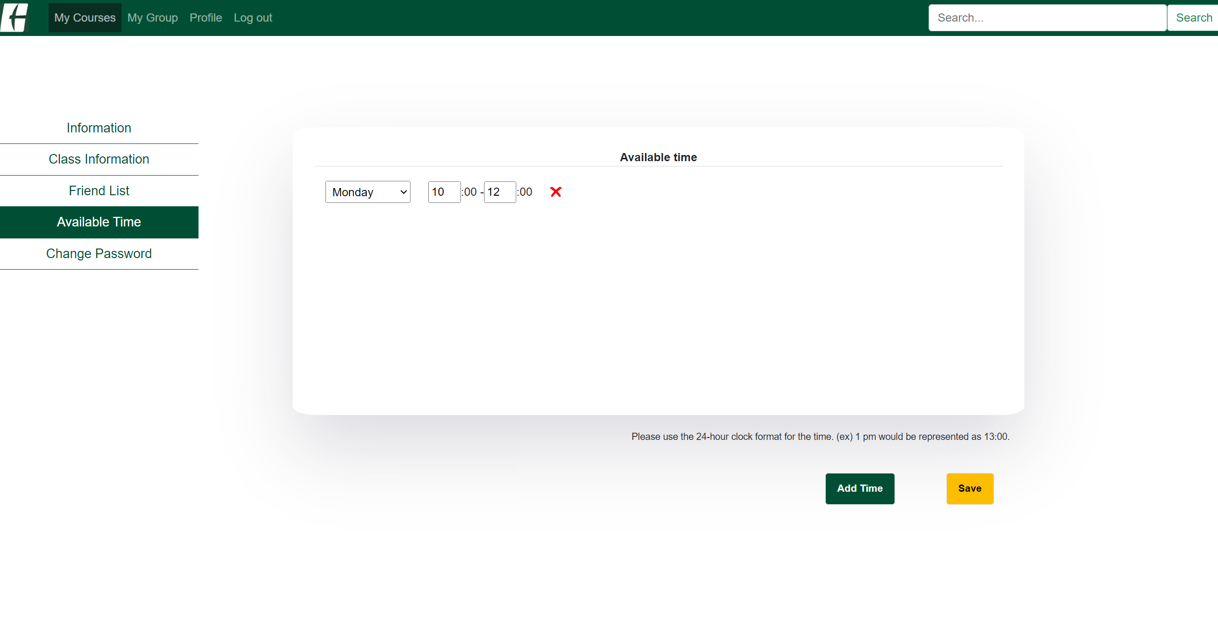

*Available time is used for scheduling a group meeting.

*Will see more later with the group feature.

*Change Password has not been implemented yet.

4. Course Page

a-1. To see a course page you enrolled, you can click the My Courses button on the menu bar.

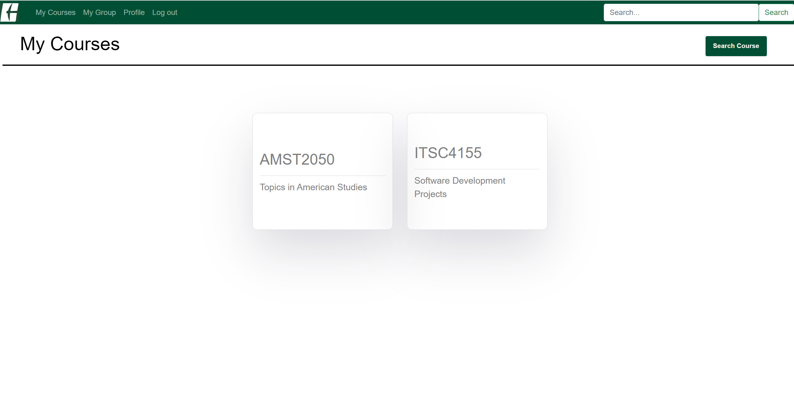

a-2. You can view the courses you're enrolled in, and by clicking on each course, you can navigate to the respective course page.

b-1. Alternatively, you can navigate to the search page by clicking the 'Search Course' button on the 'My Courses' page or searching for a course directly on the main page.

b-2. Once you find your class, click Search button to see the result. Click the result to go to the Course main page.

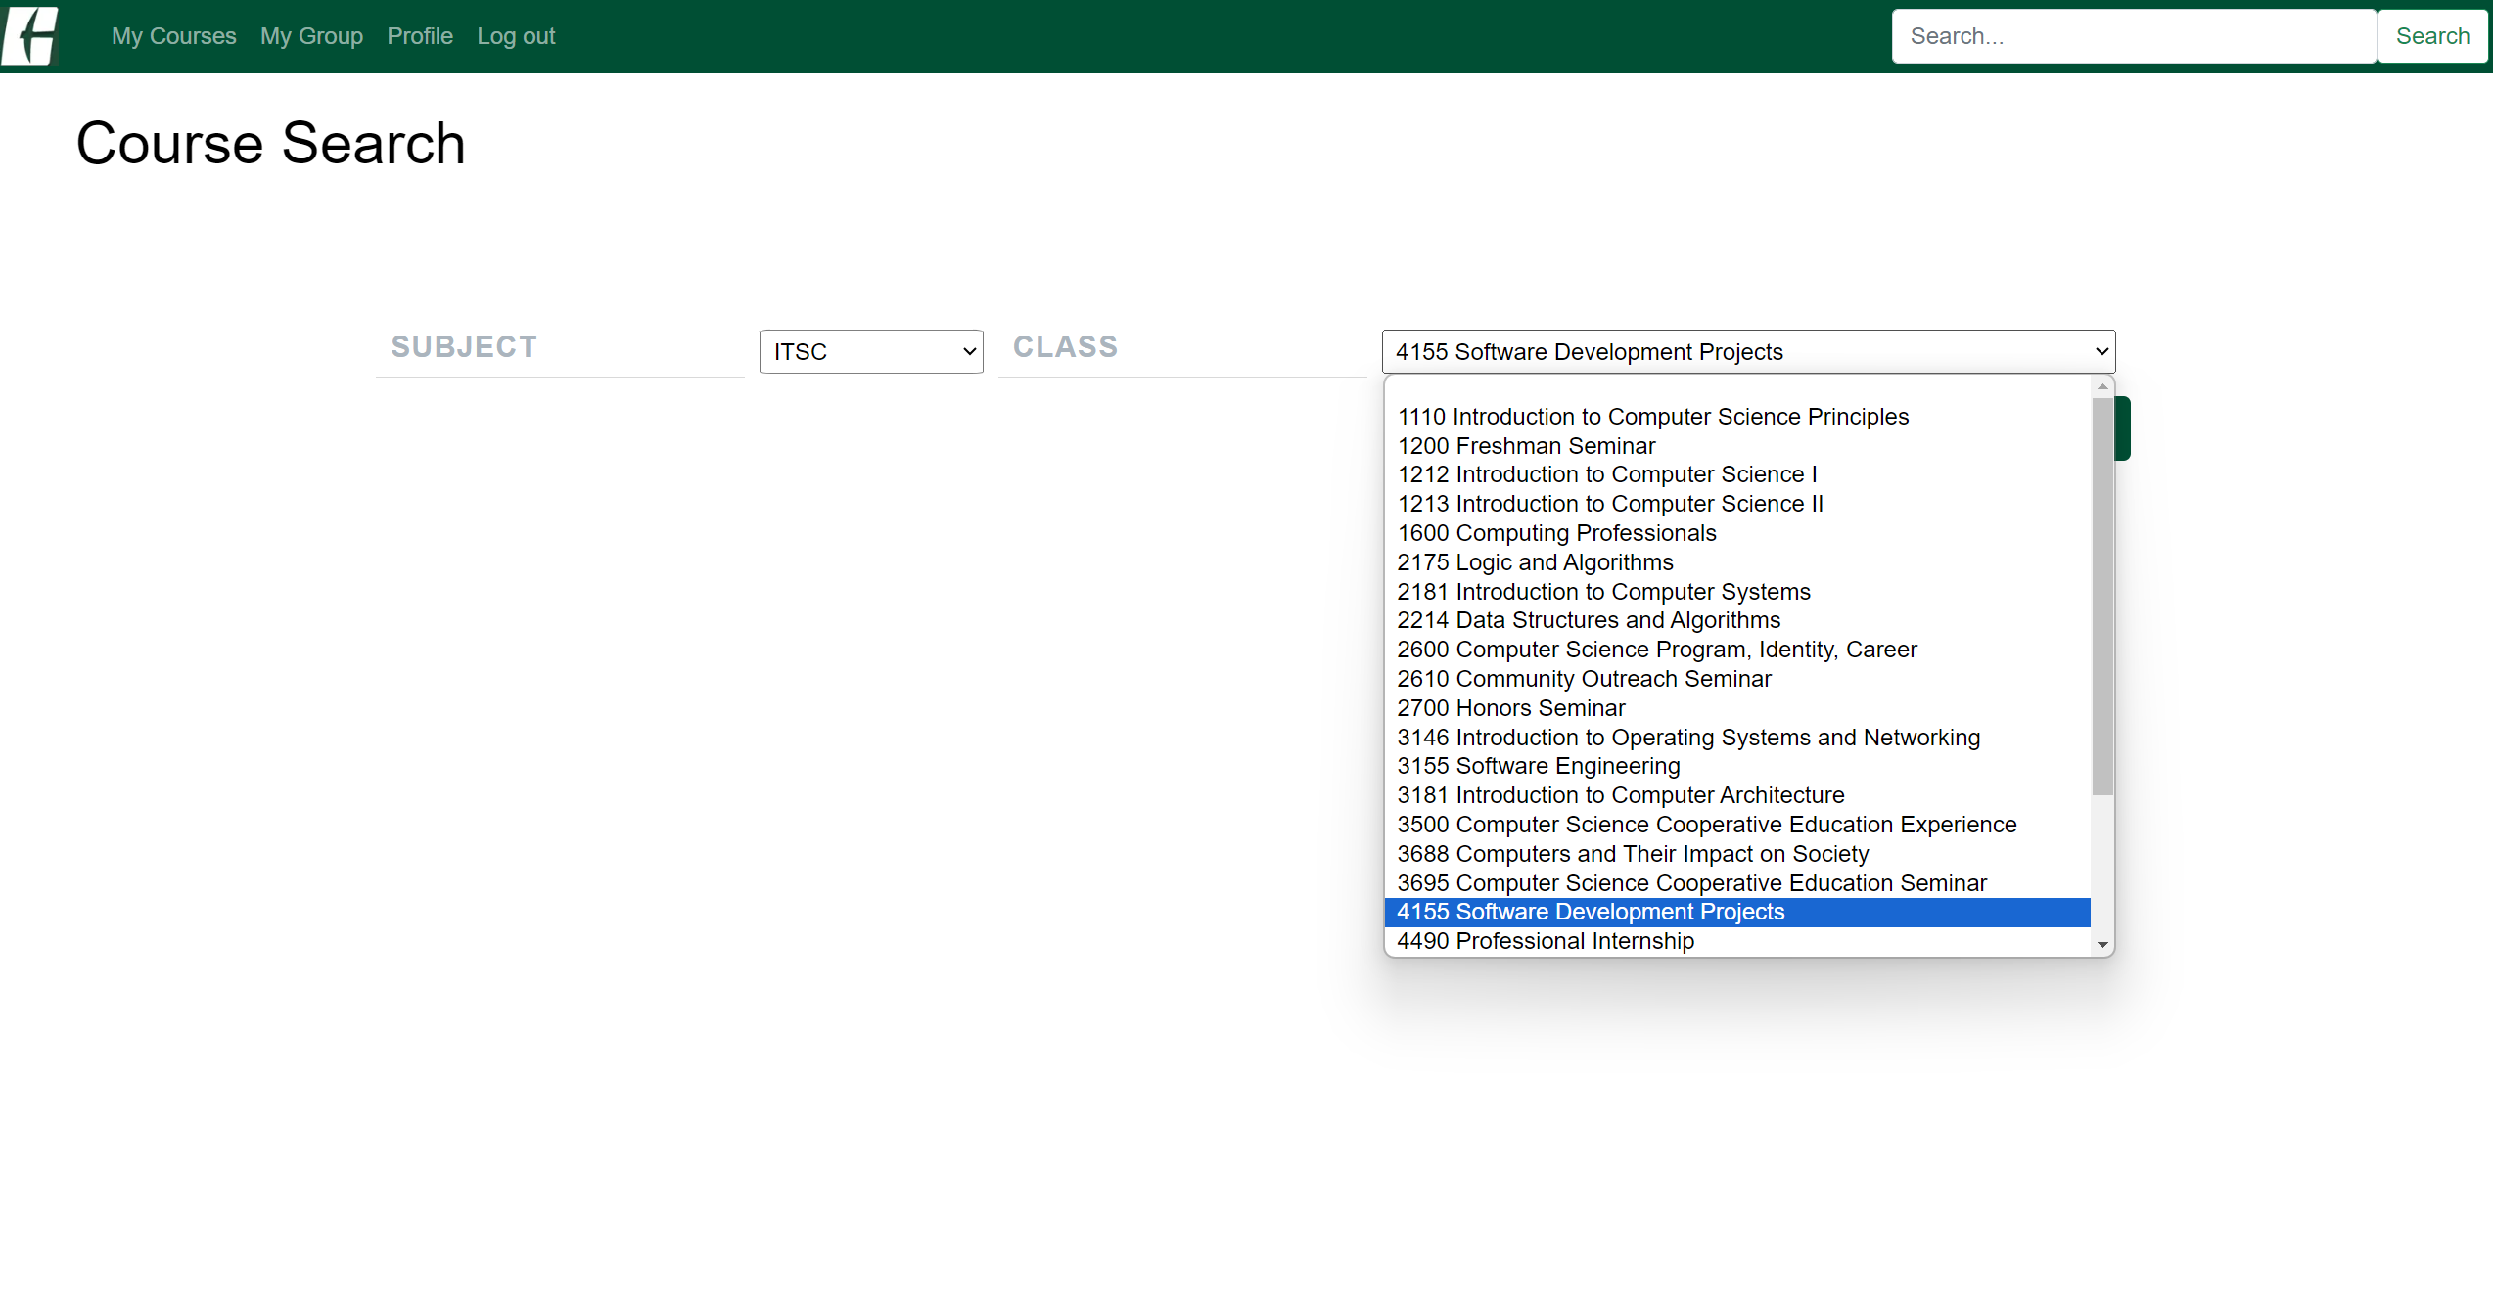

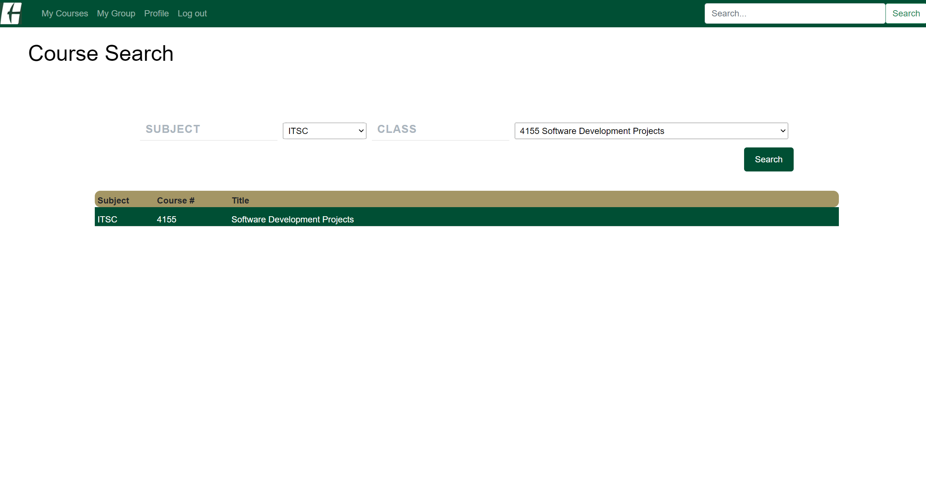

c. You can create a post, a study set, and a group on the course main page.

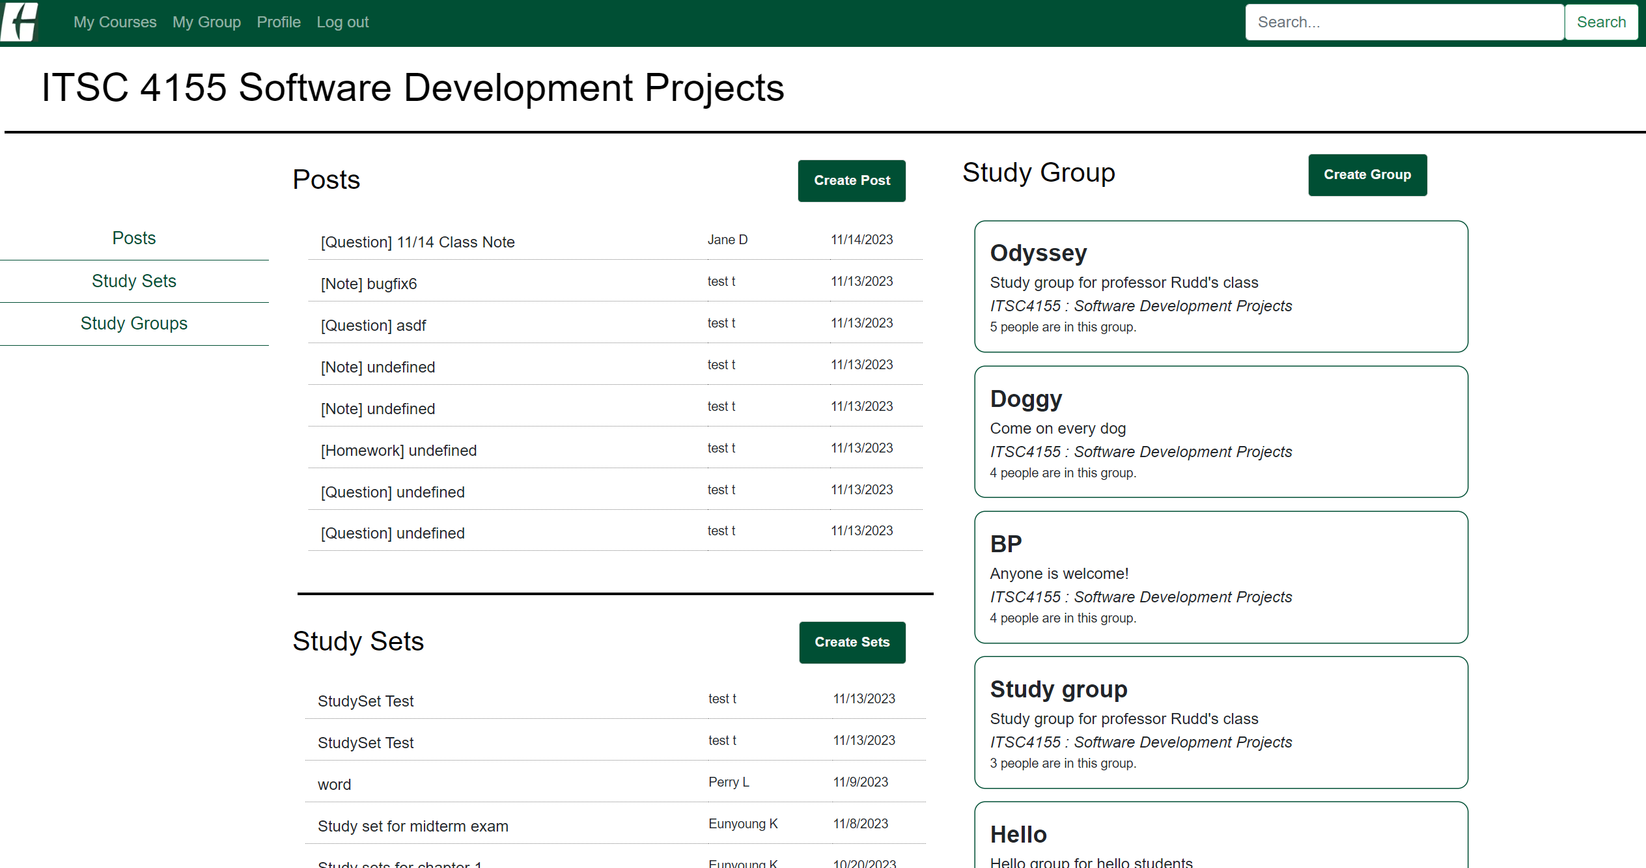

d. If you are not enrolled in the course, you can click the Enroll button to get permission to create things.

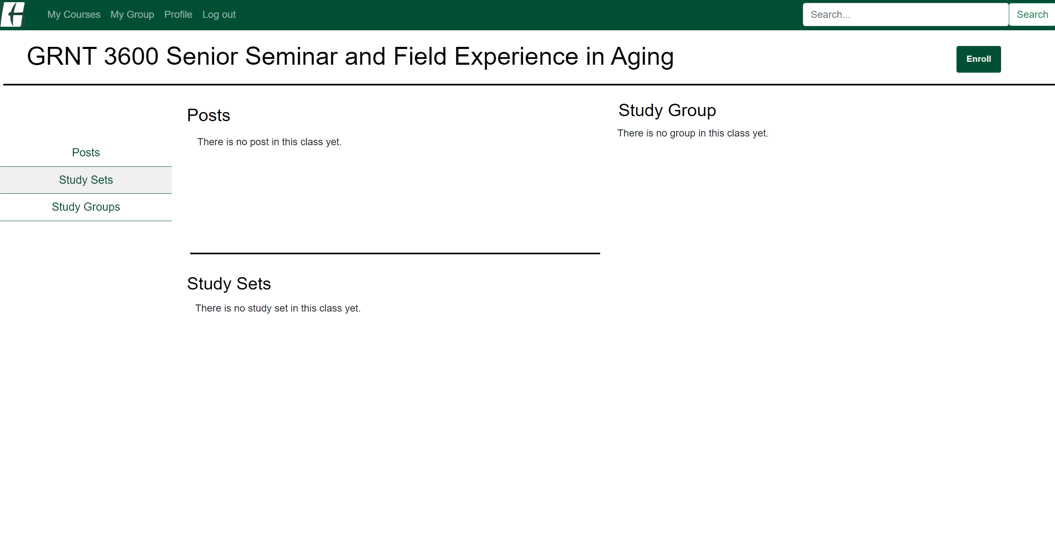

e. You can use left menu to go to the Posts, Study sets, and Study Groups list in this course.

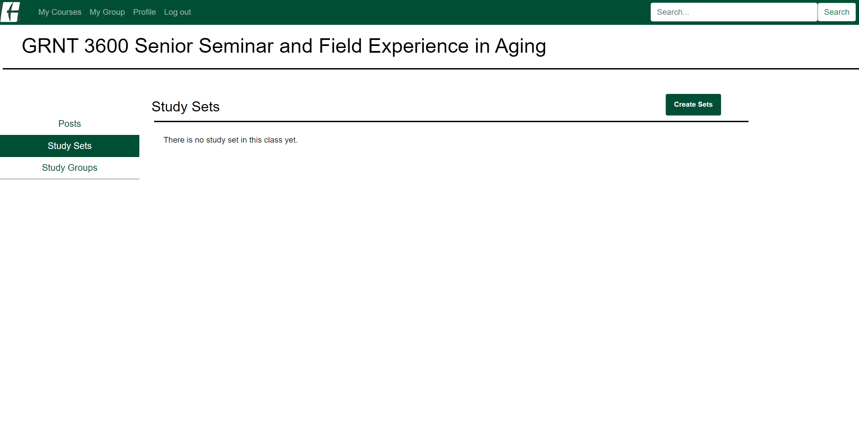

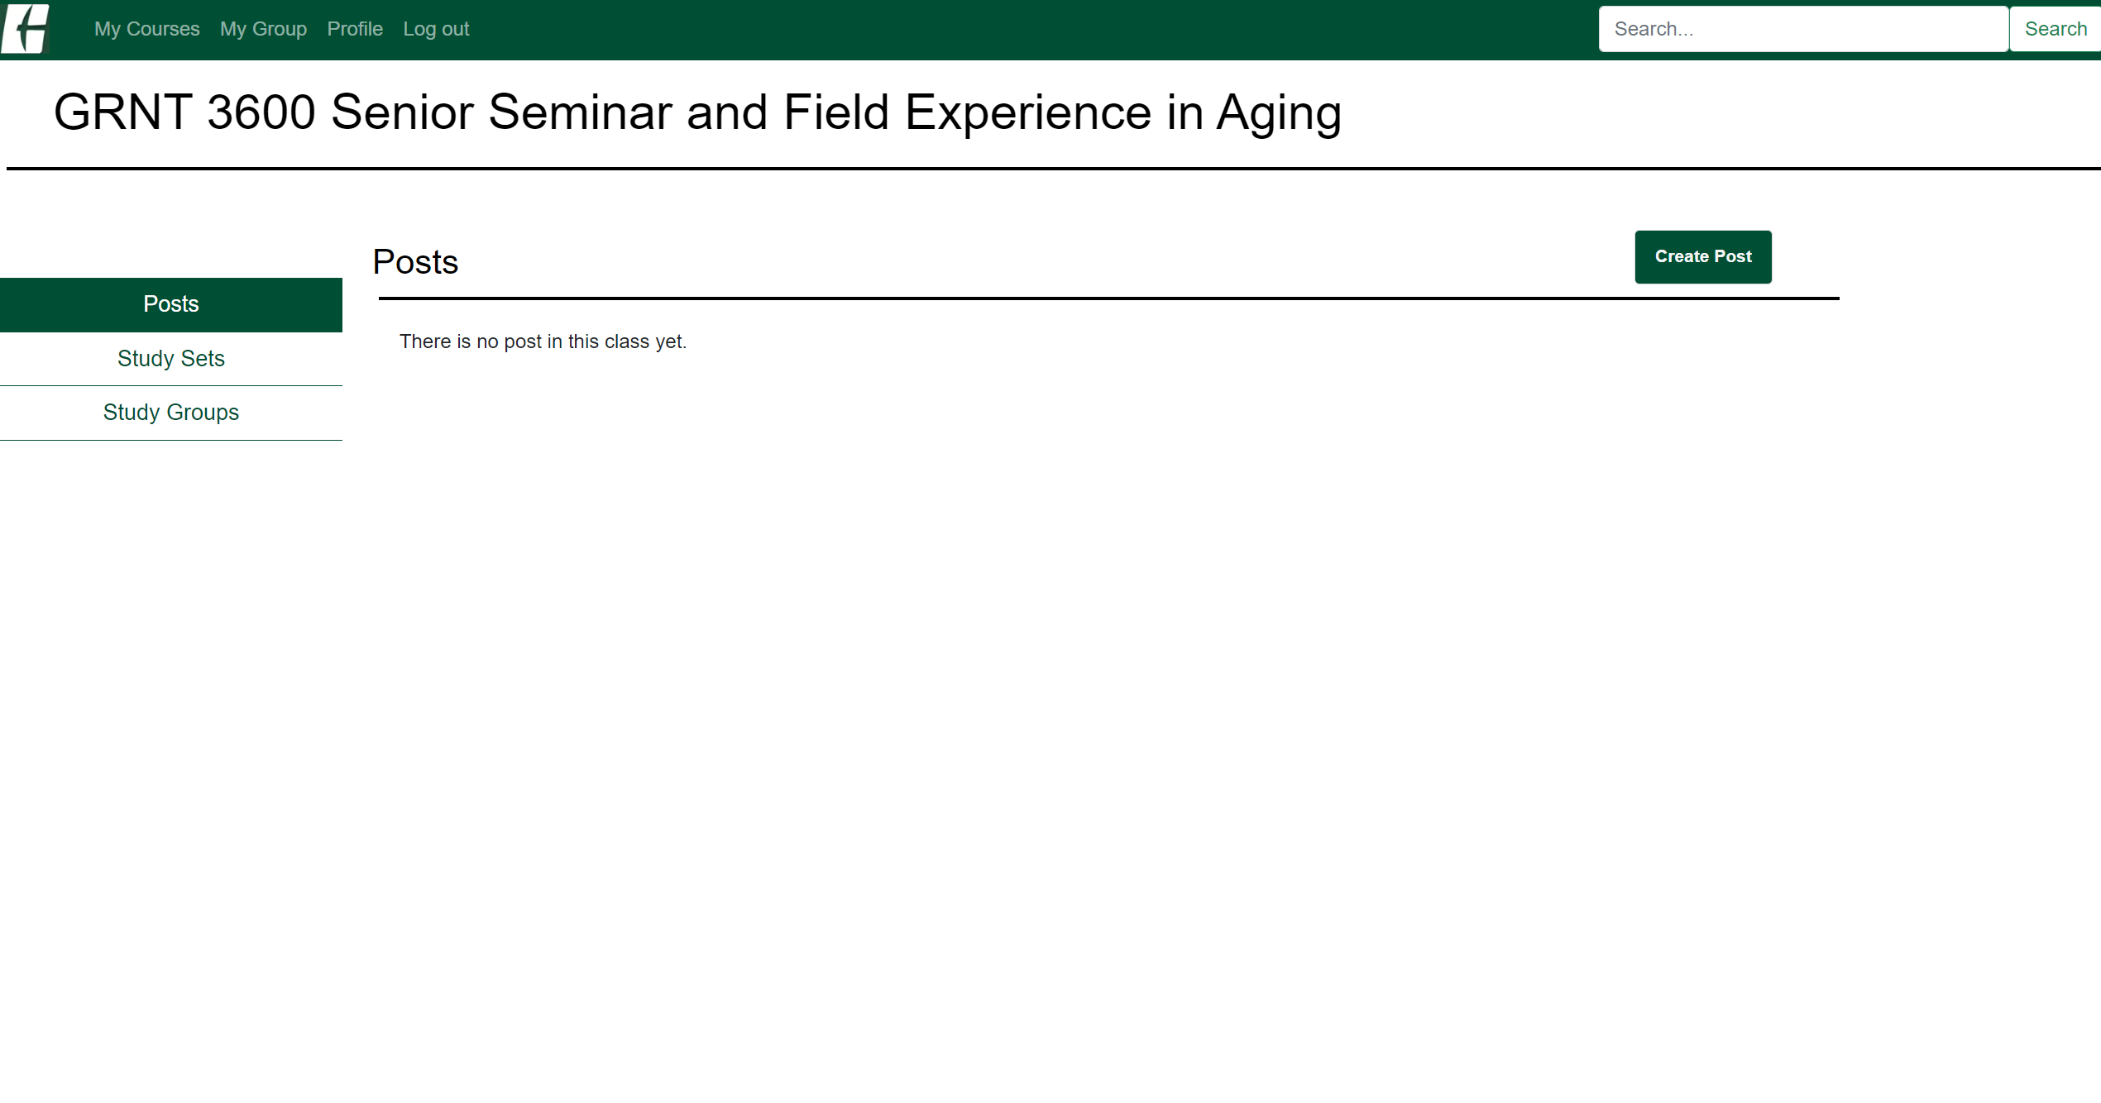

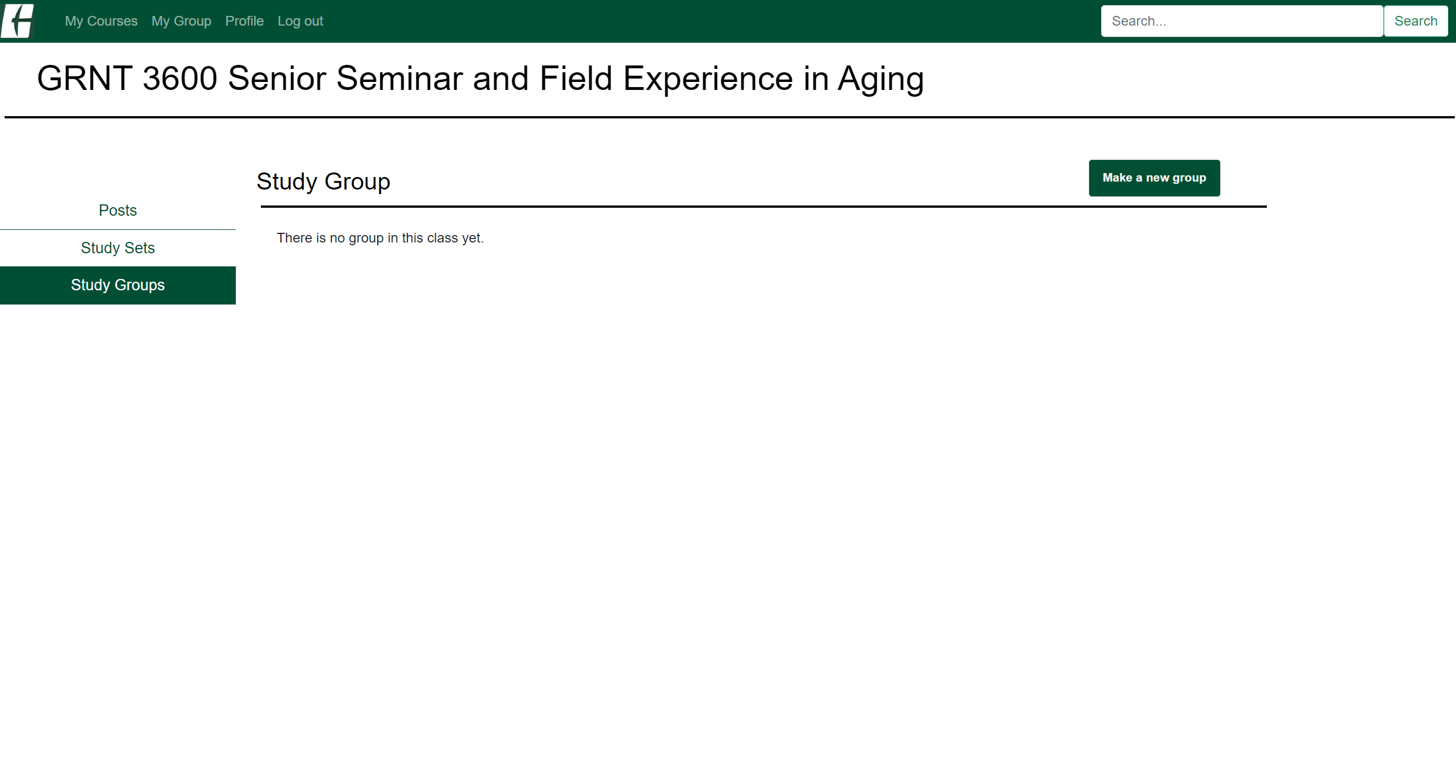

f. You can click the Course title (in this screenshot, GRNT 3600 Senior Serninar and Field Experience in Aging) to go back to the course main page.

4-1. Create post, study sets, and study group

a-1. When you click the Create Post button in the course main page or post page, it navigates you to the posting page.

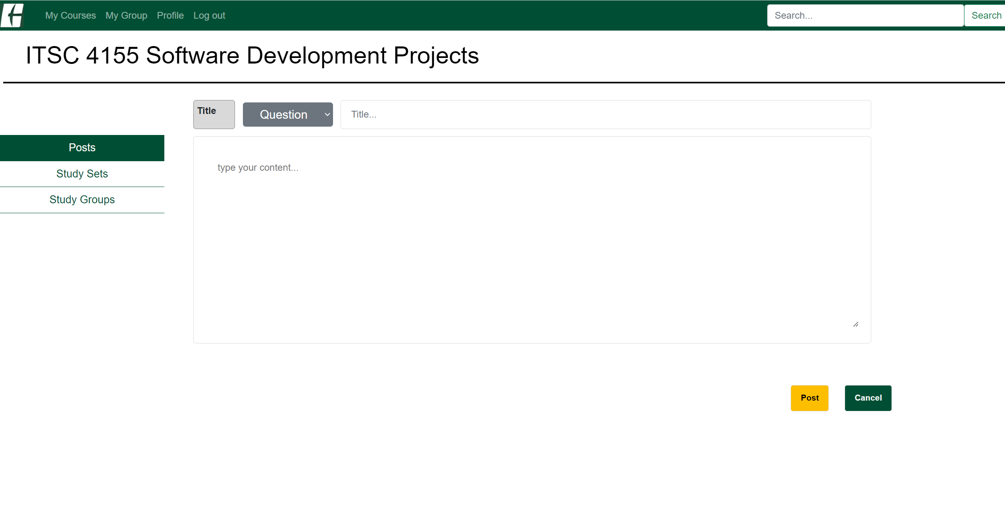

a-2. You can choose the category and create a post by clicking post button.

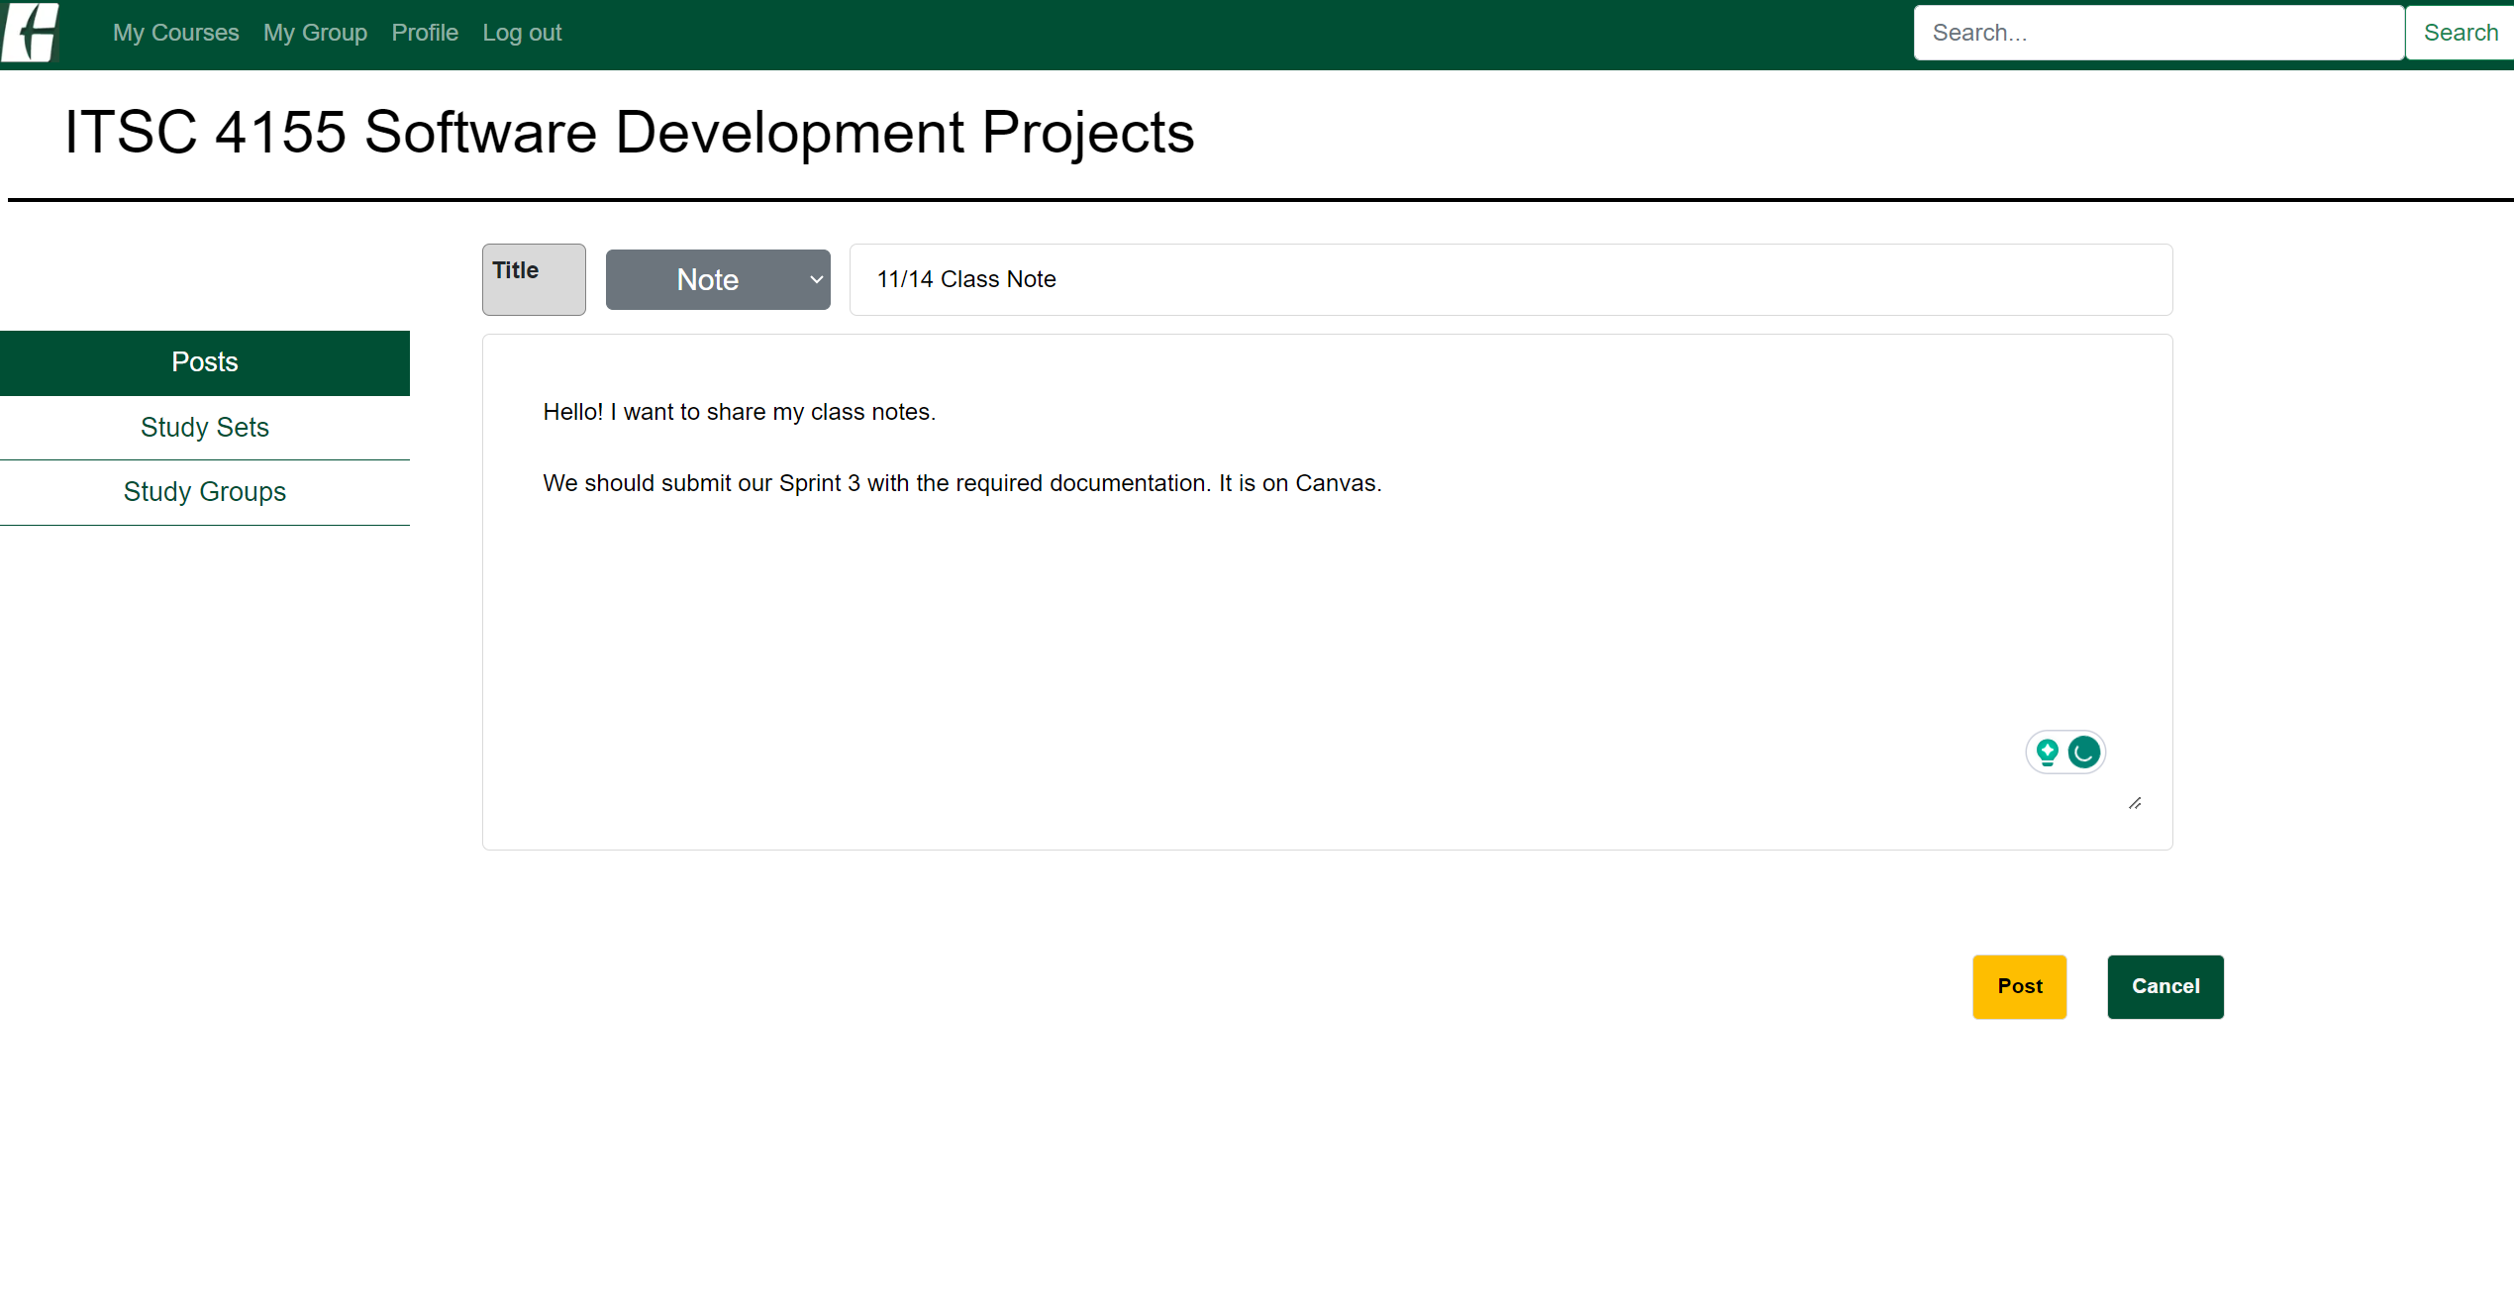

a-3. You can see your post on the posting page.

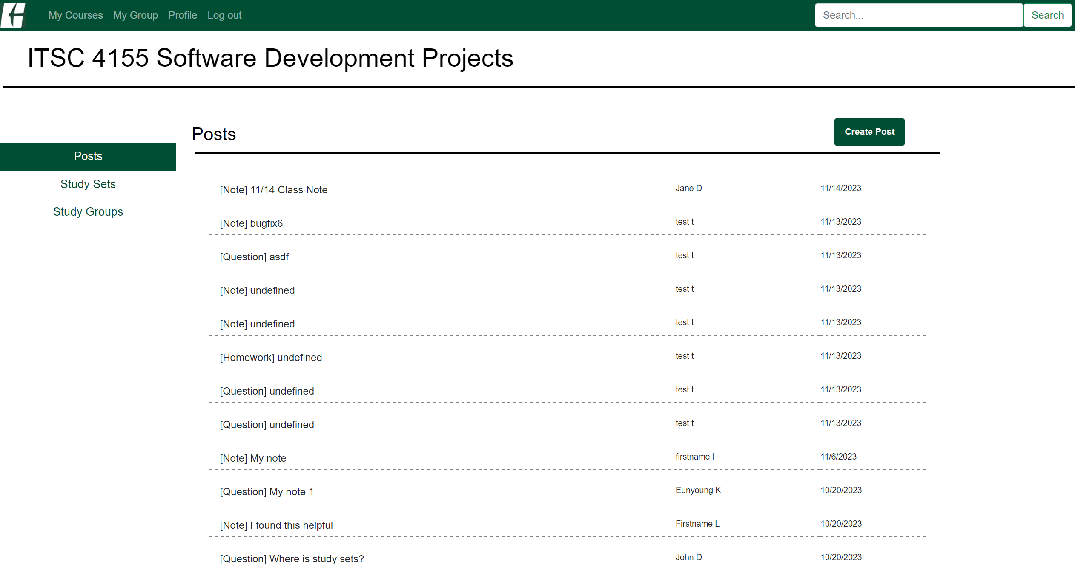

a-4. You can click the list to see the post.

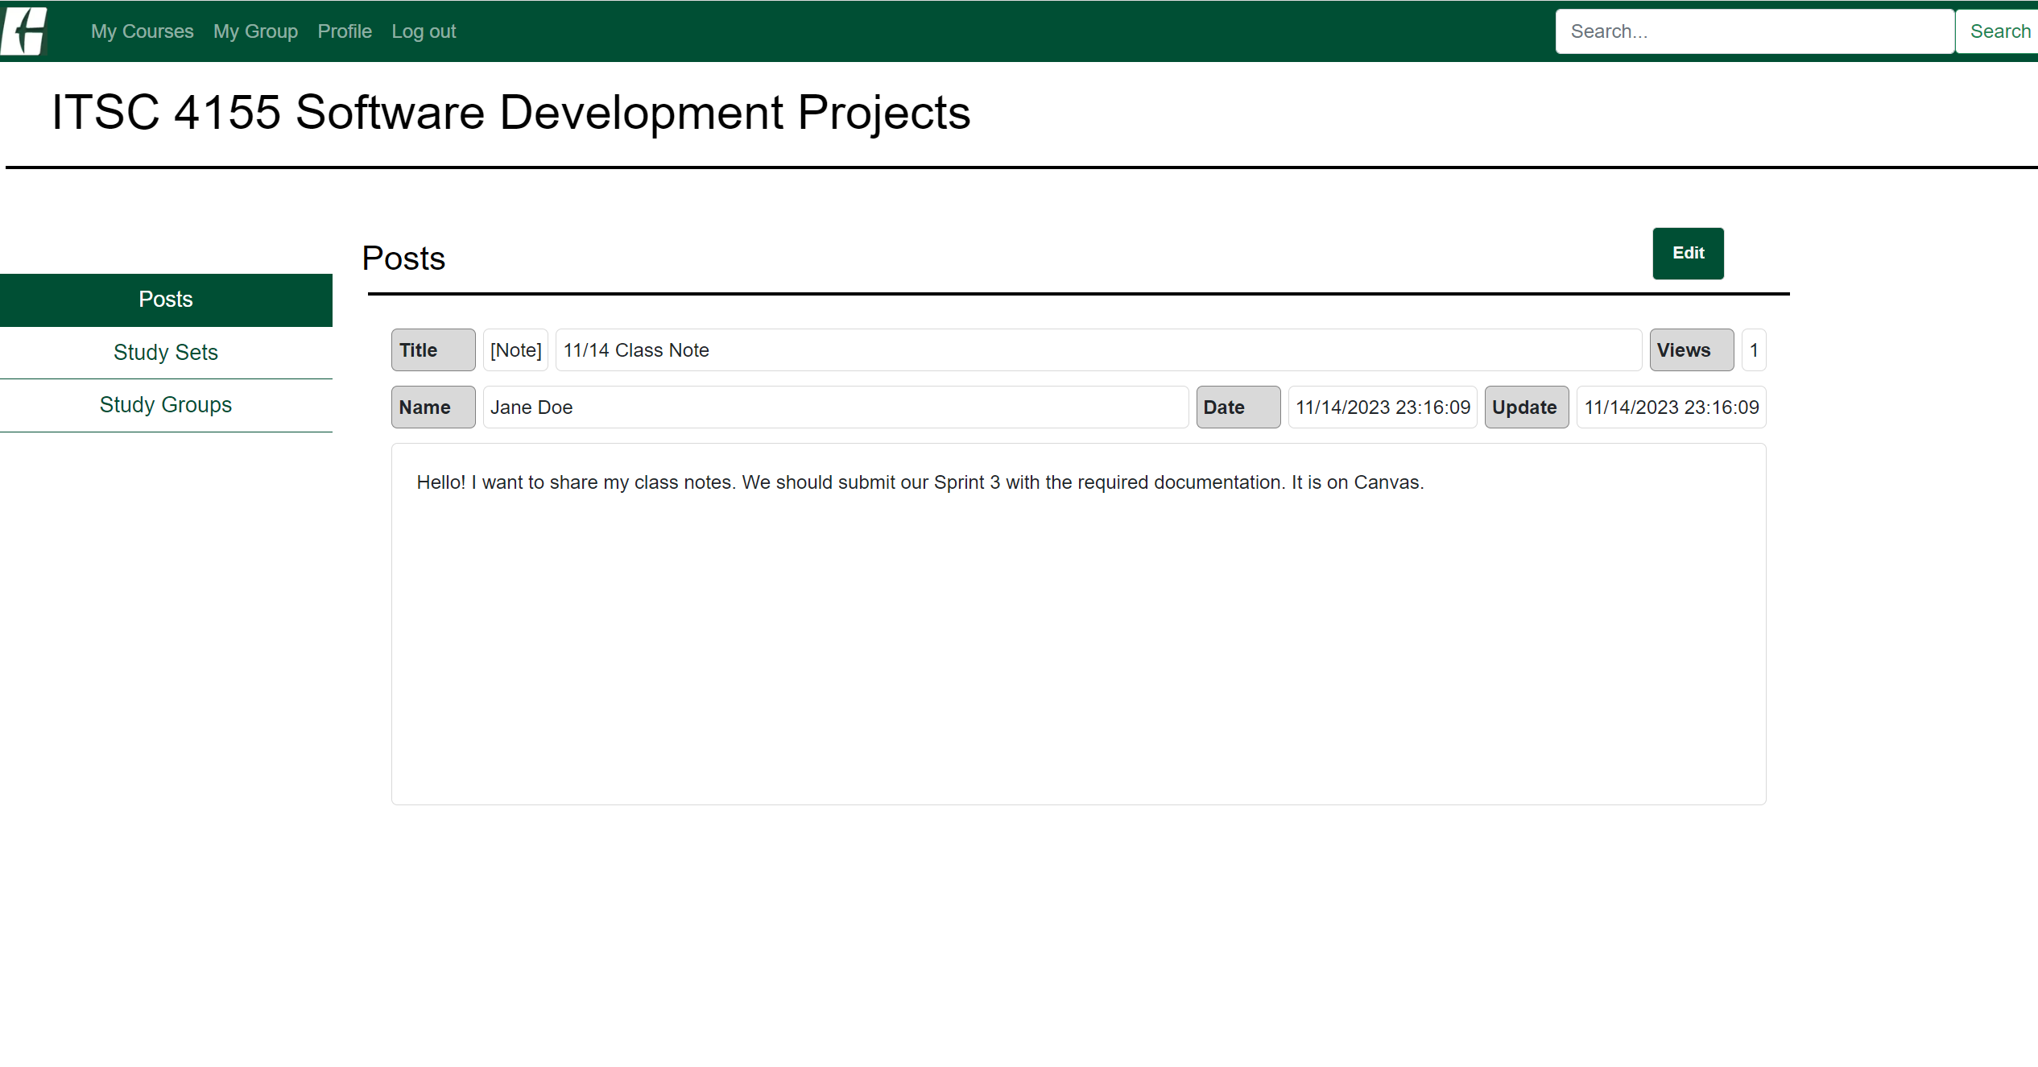

a-5. To edit your post, click the Edit button and hit Save once you've finished editing your post.

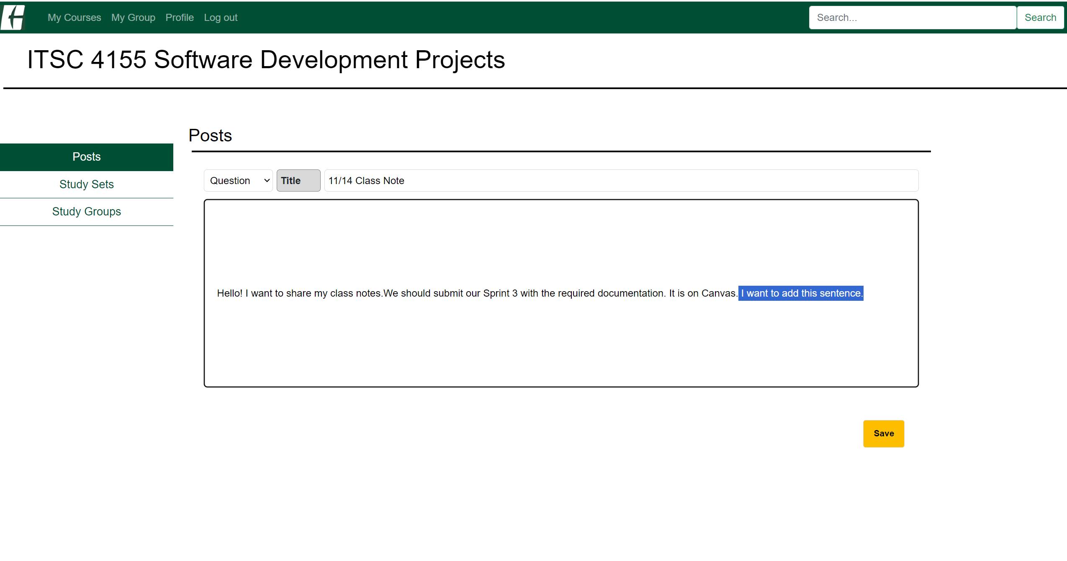

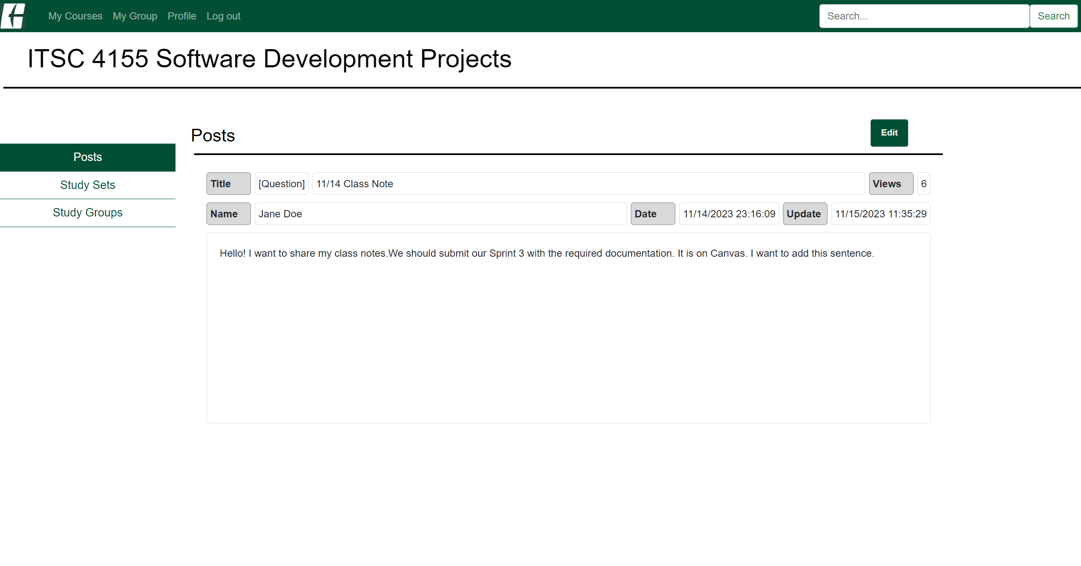

b-1. To make a study set, click the Create Study Set button in the course main page or study sets page.

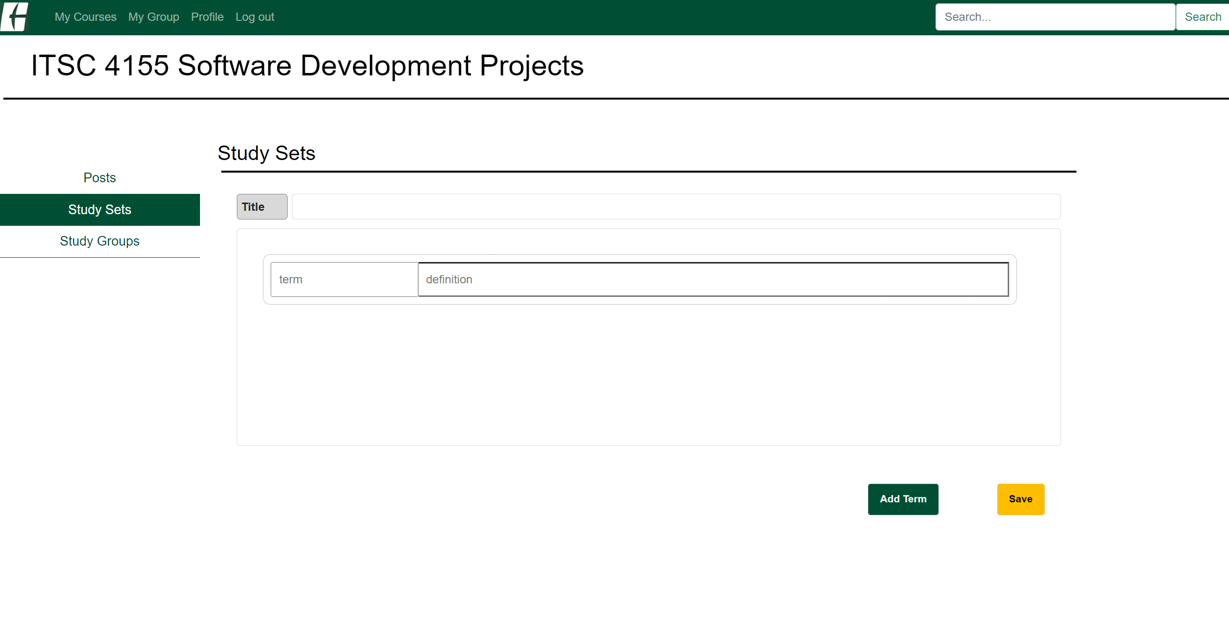

b-2. To add more terms in your study set, you can hit the button Add Term.

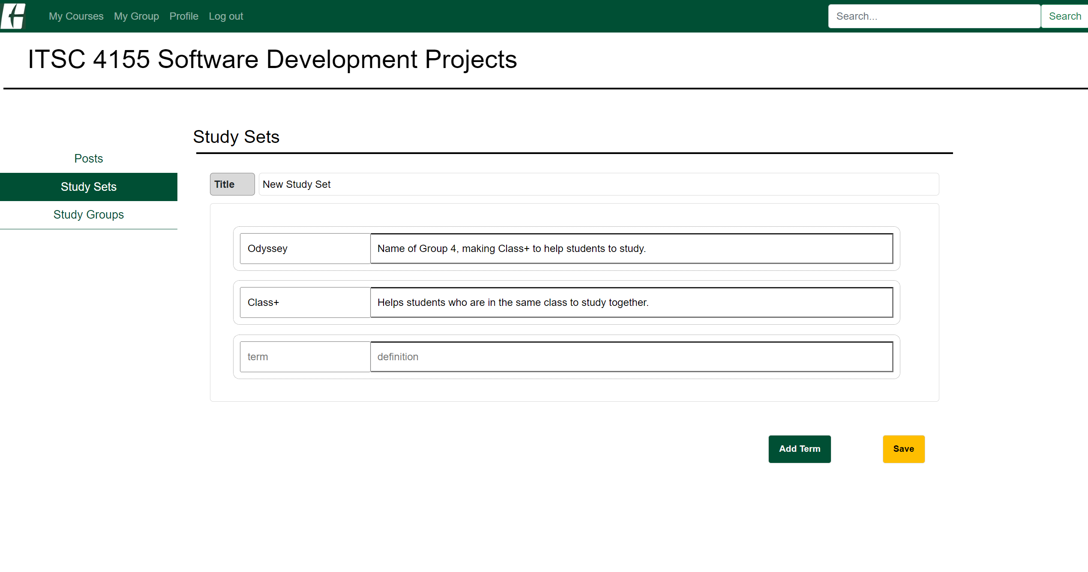

b-3. Once you finished to enter the terms, hit the save button. Then you can see your study set on the list.

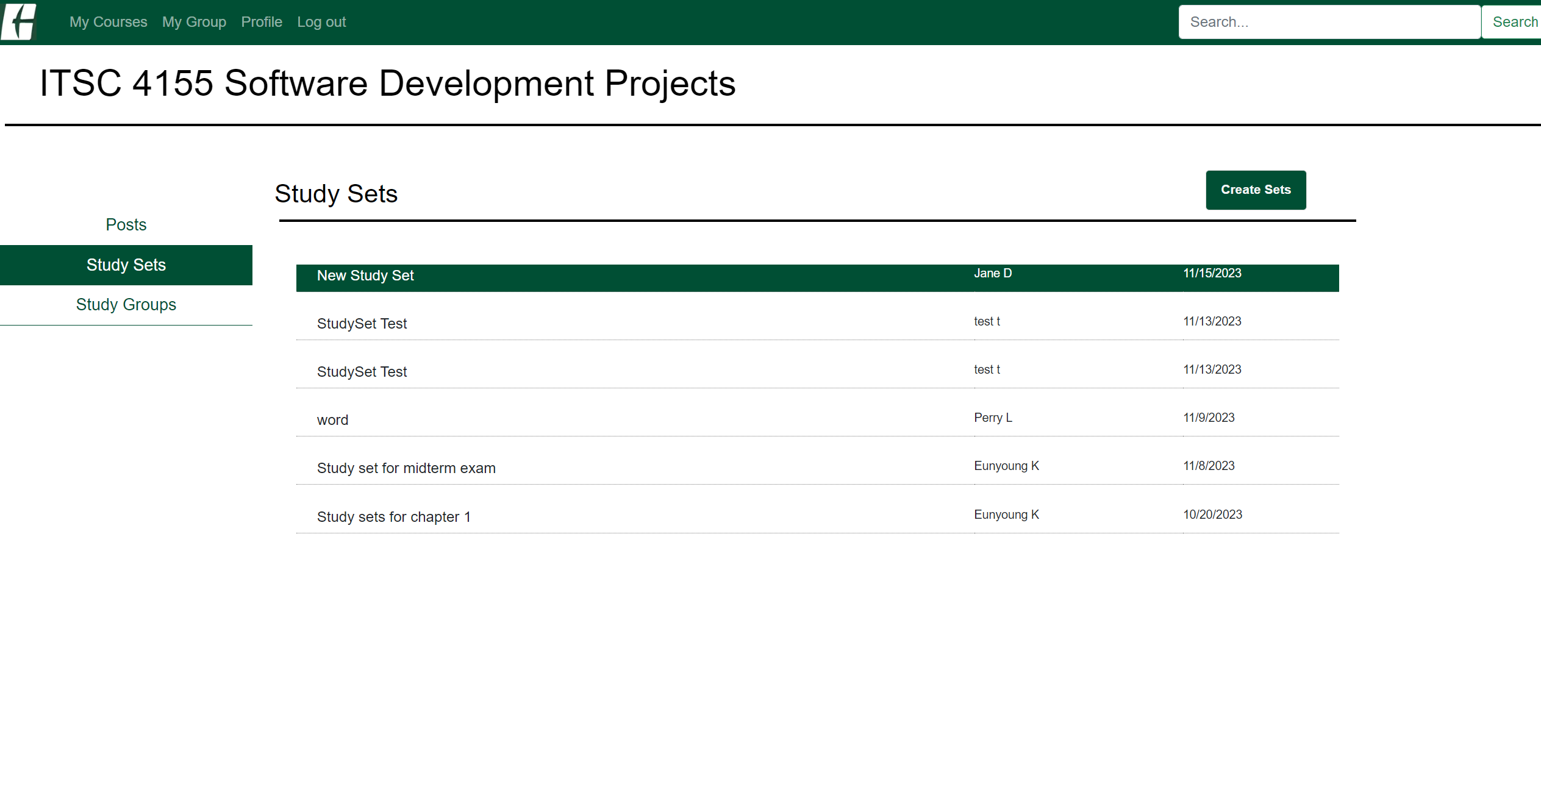

b-4. To see your study set, click your study set on the list.

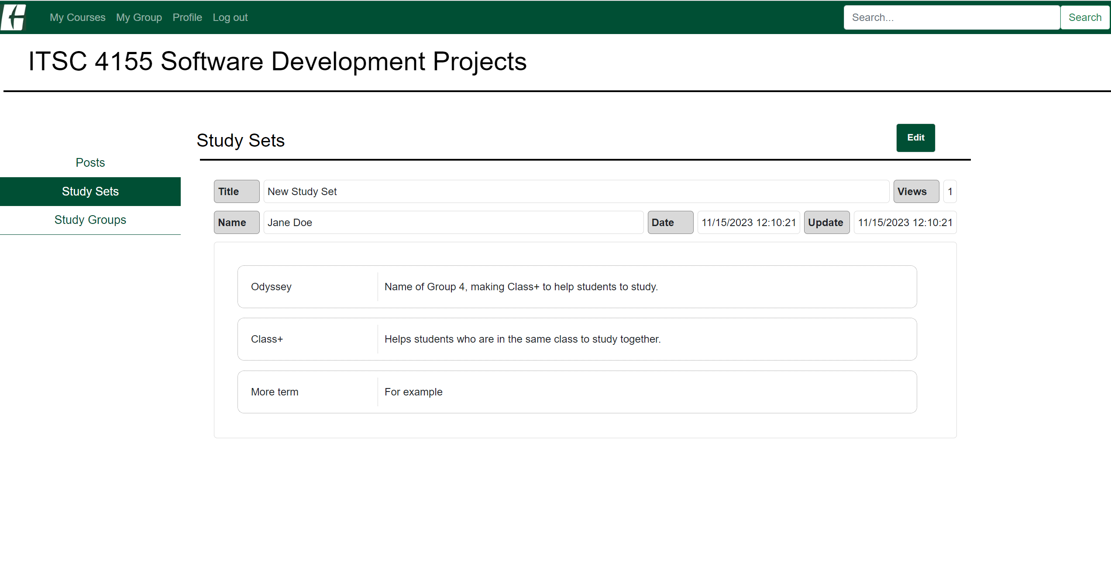

b-5. You can also edit them as you did with the post. But editing is not allowed to add more terms to the existing study set.

c-1. To make a study group, click the Create Group button in the course main page or Make a new group in the study group page.

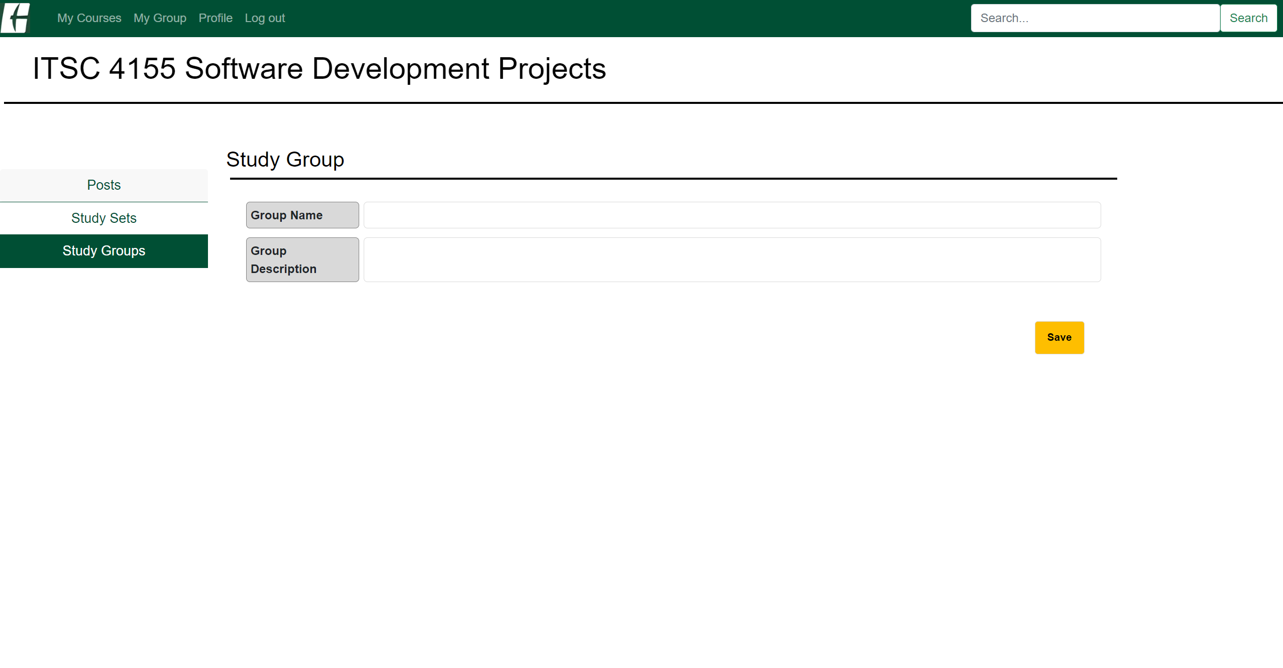

c-2. Once you fill in the Group Name and Group Description, click Save.

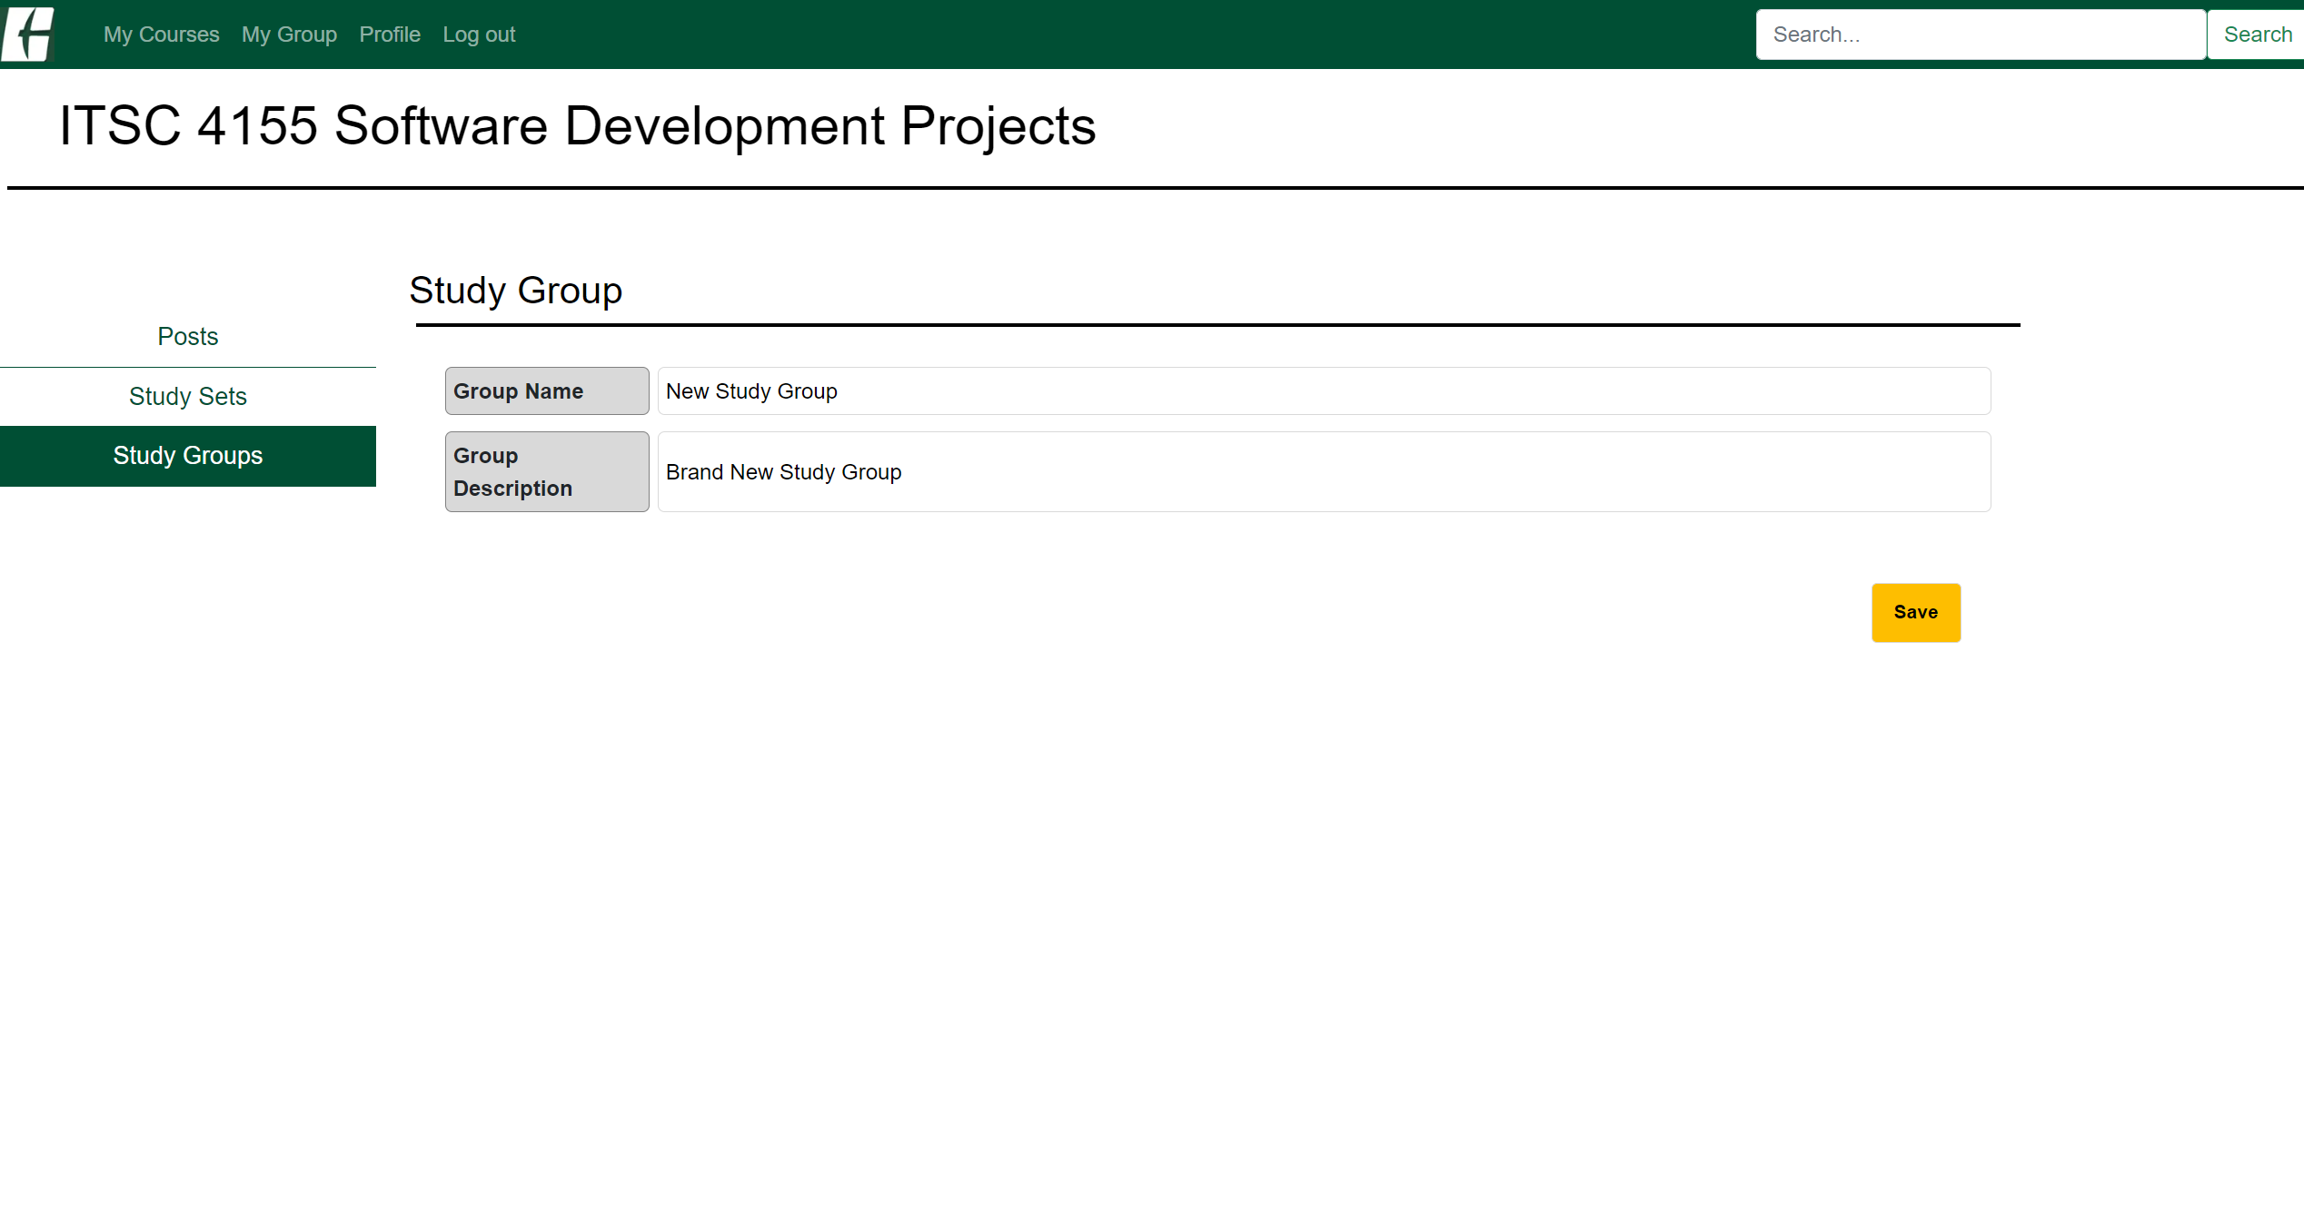

c-3. You can see your study group in the study group page.

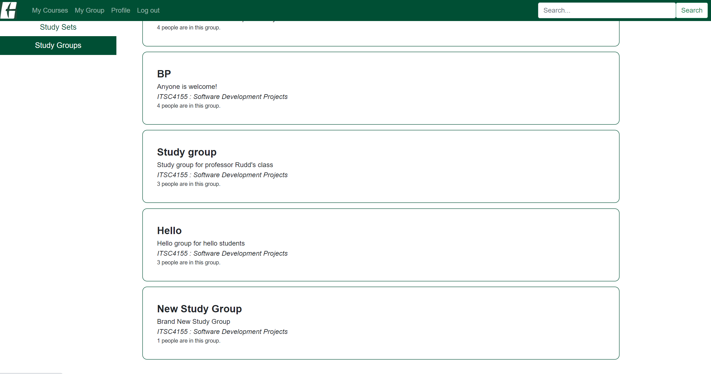

c-4. Or you can see your study group in the My Group page on the menu bar.

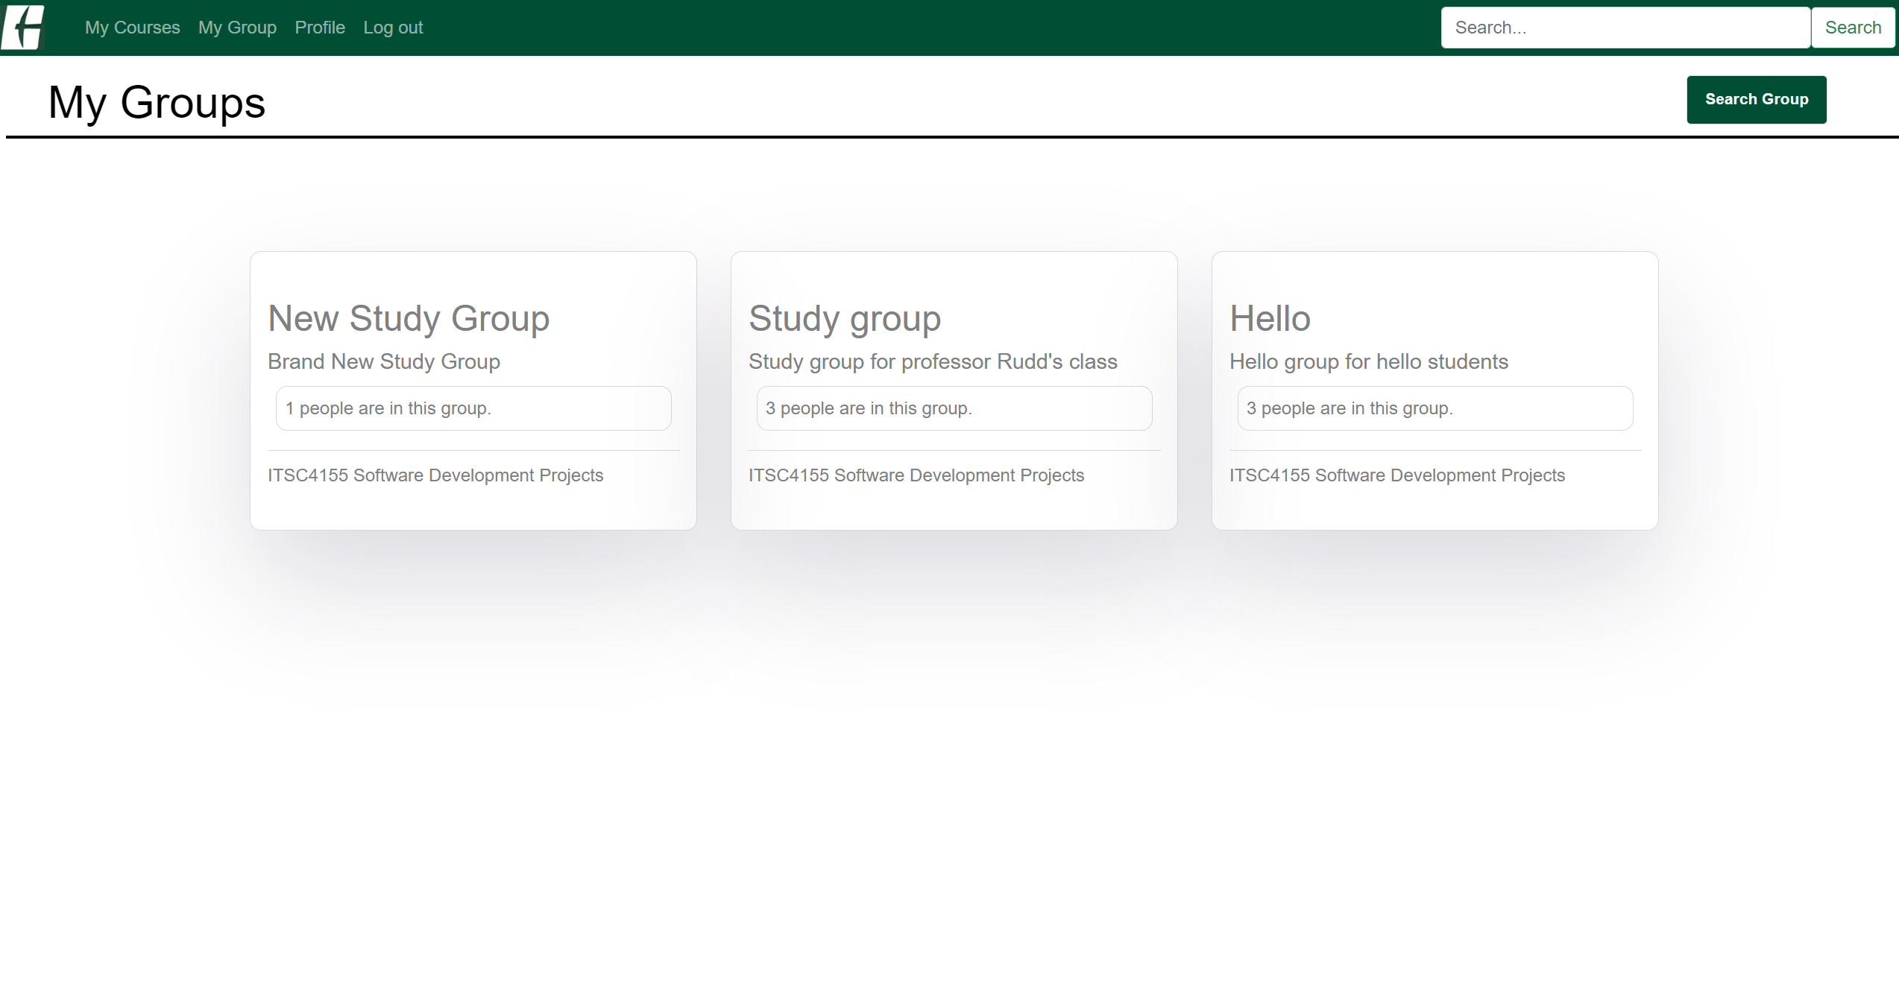

5. Study Group

a. As seen above, study groups can be found on the Course page or My Group page.

b. Or you can search a study group by clicking the Search Group button on the My Groups page or Search for a group button on the main page.

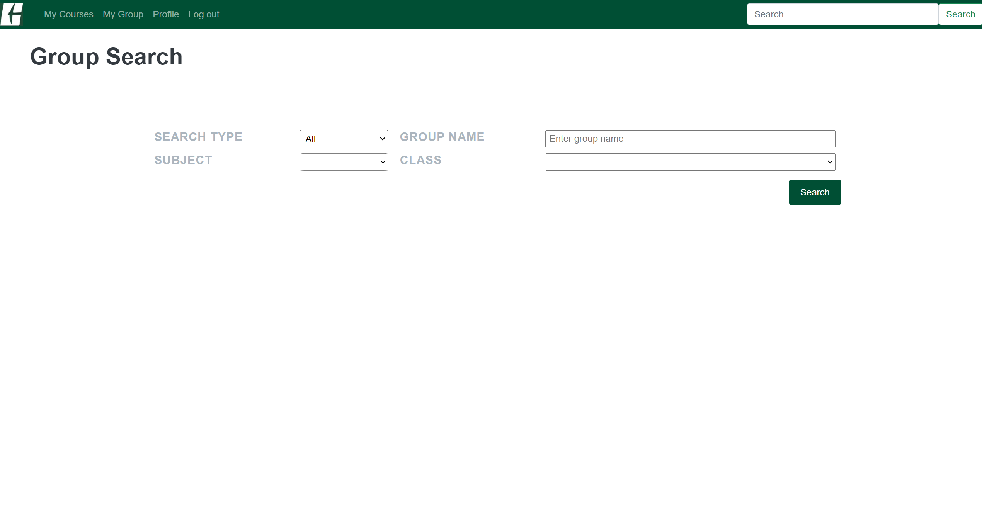

c. You can search for a group by course, group name, or with both options.

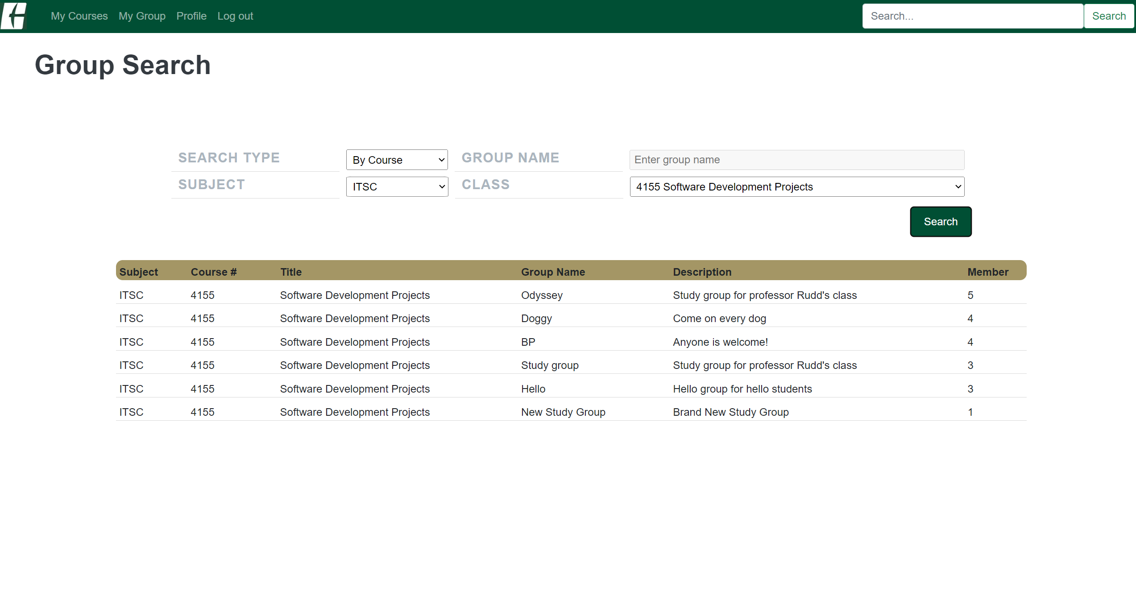

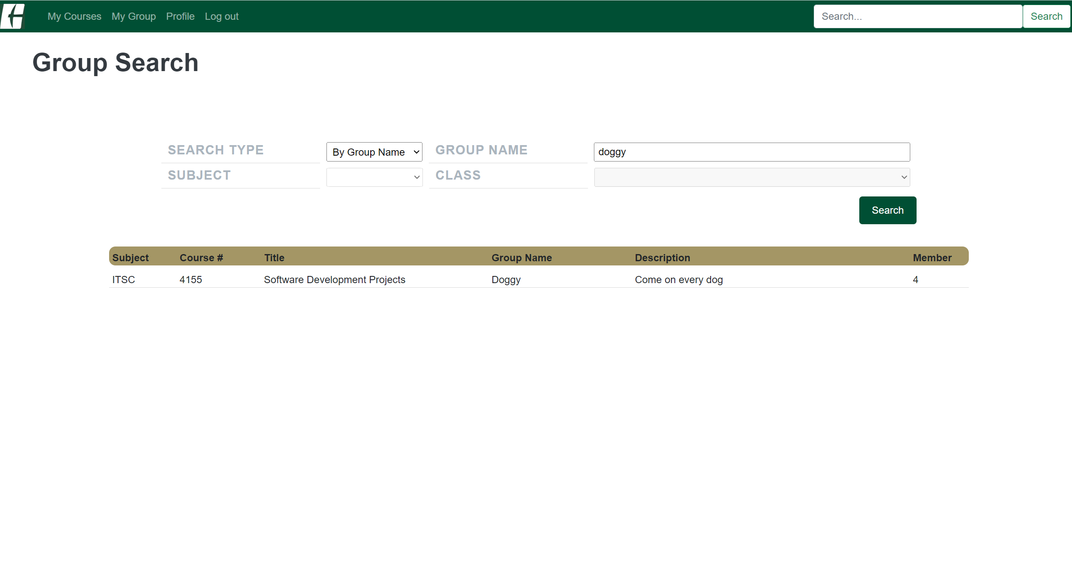

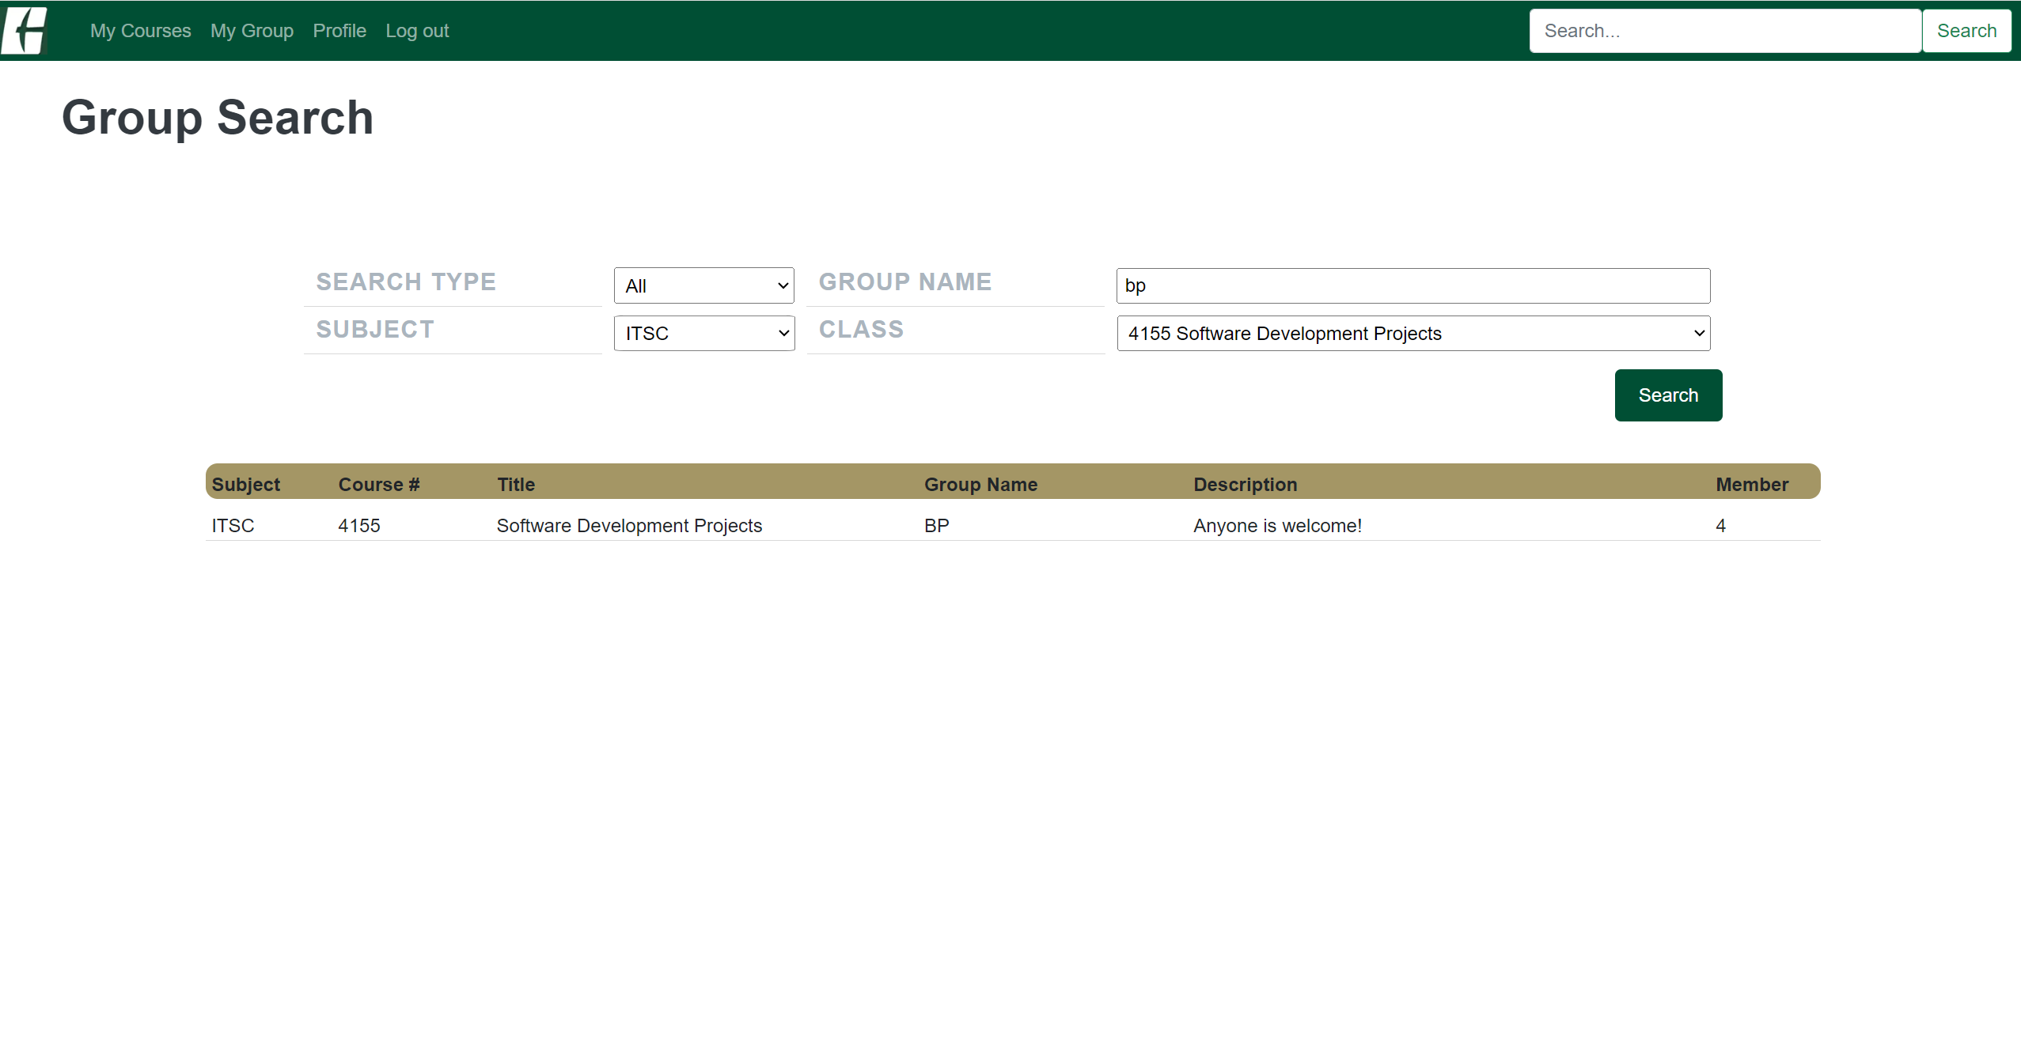

d. When you click the group in any page you got the group (Course page, My Group page or Group Search page), you can see the Group Main page.

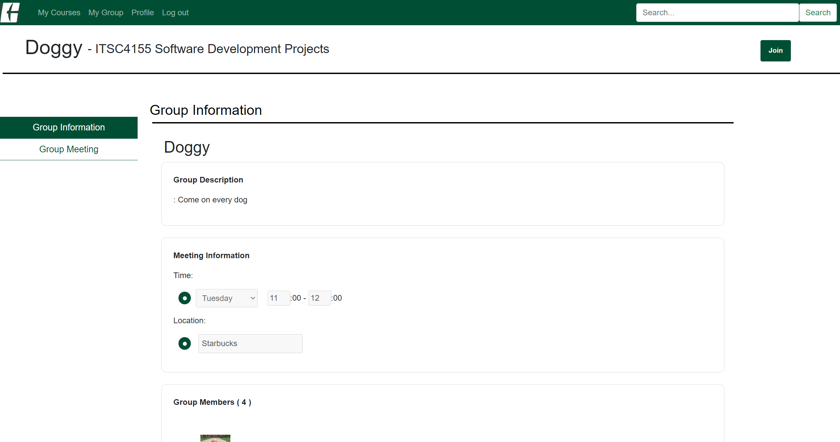

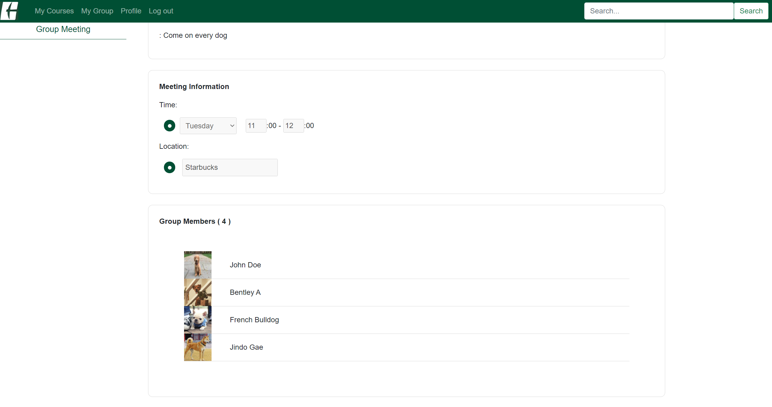

e. To see the Group Meeting page, click Group Meeting on the left menu bar.

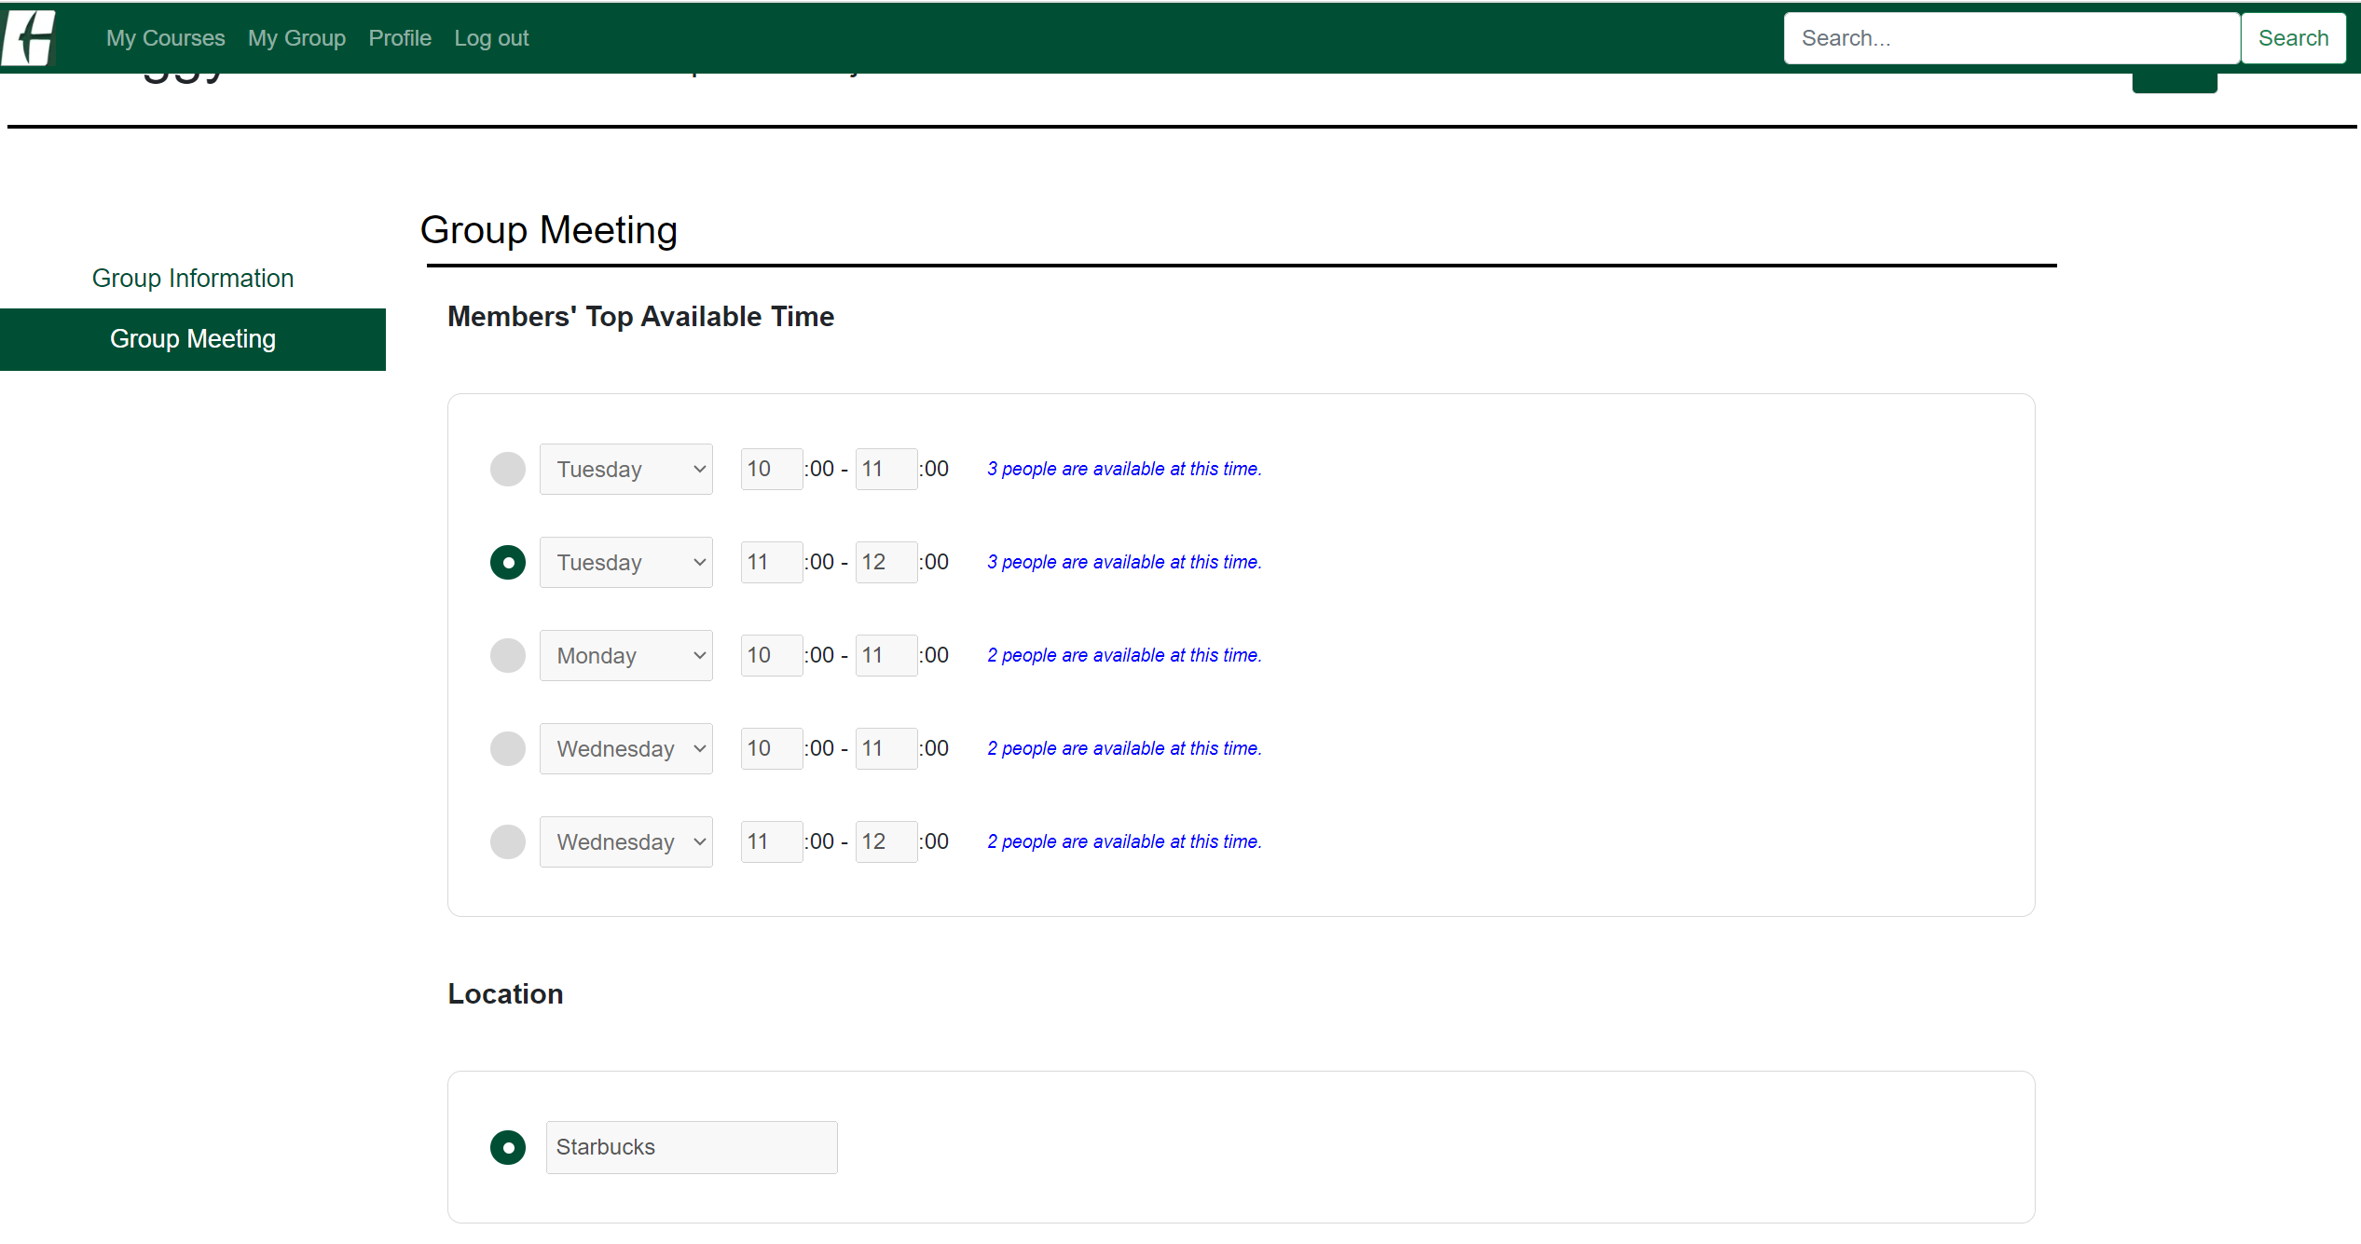

f. If you want to adjust the Meeting time and Location, or follow a new friend from this group, you should join to this group by clicking Join button. Once you join to this group, you will be able to do them.

*You must be enrolled to the course that the study group in.

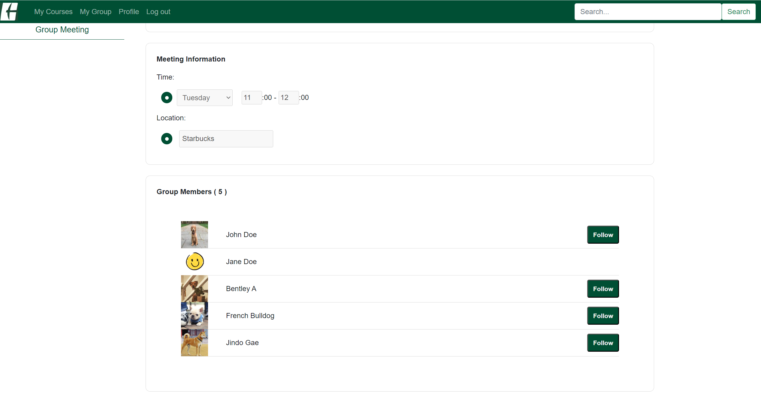

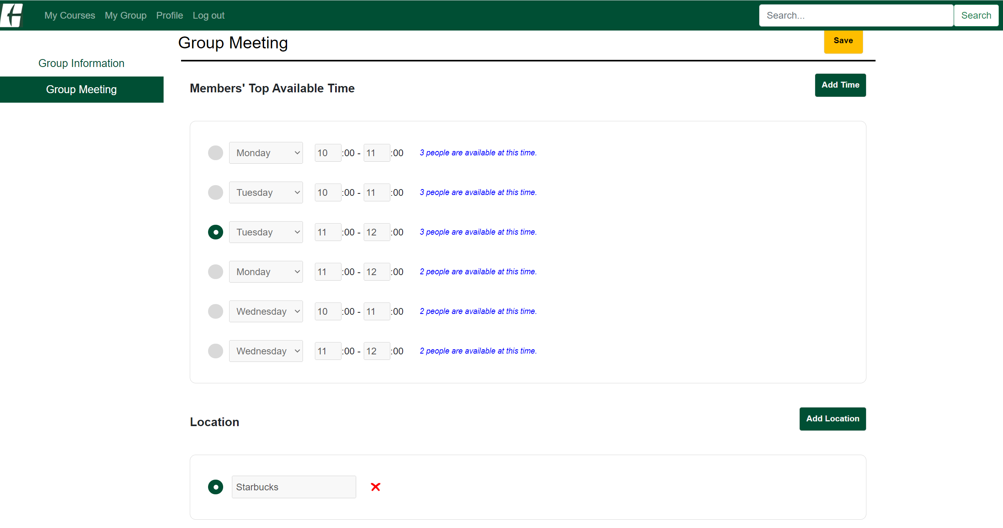

f-1-1. You can follow members on ths Group Members section on the Study Group by clicking Follow button.

f-1-2. Once you follow a member, you can see them in your friend list, in the Profile.

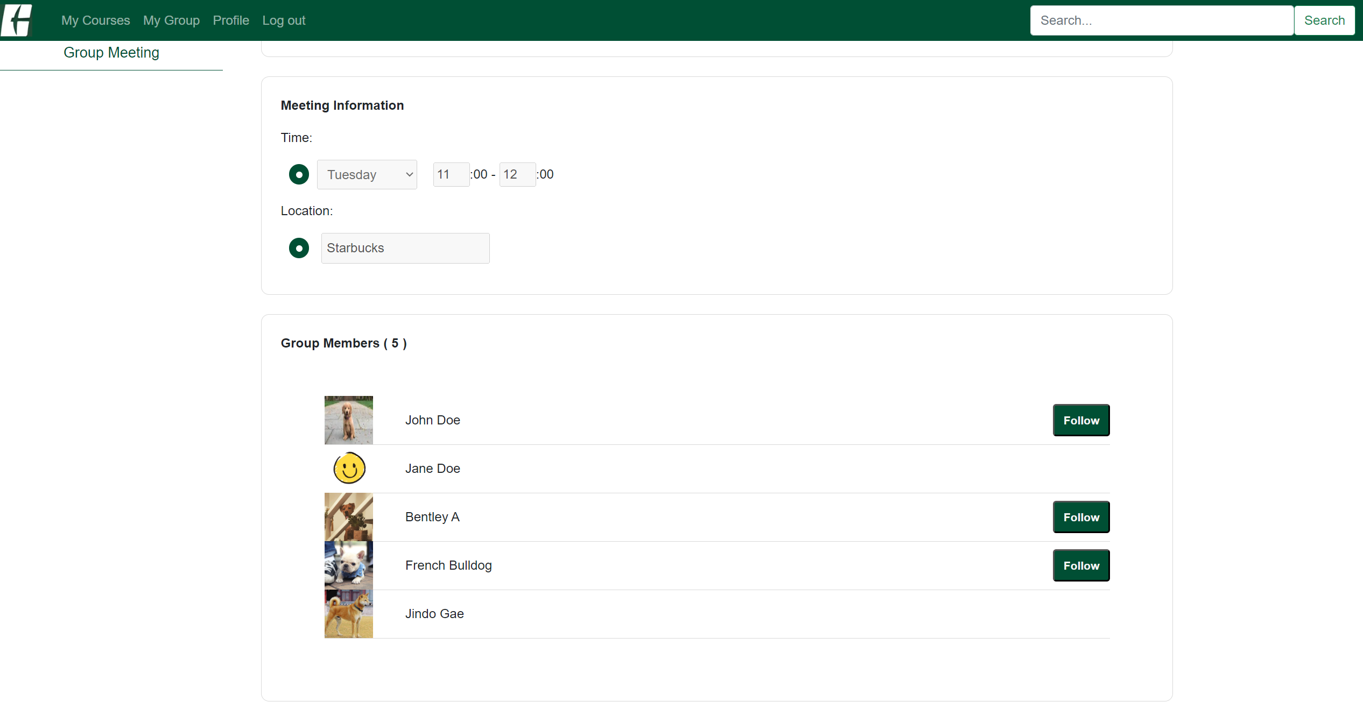

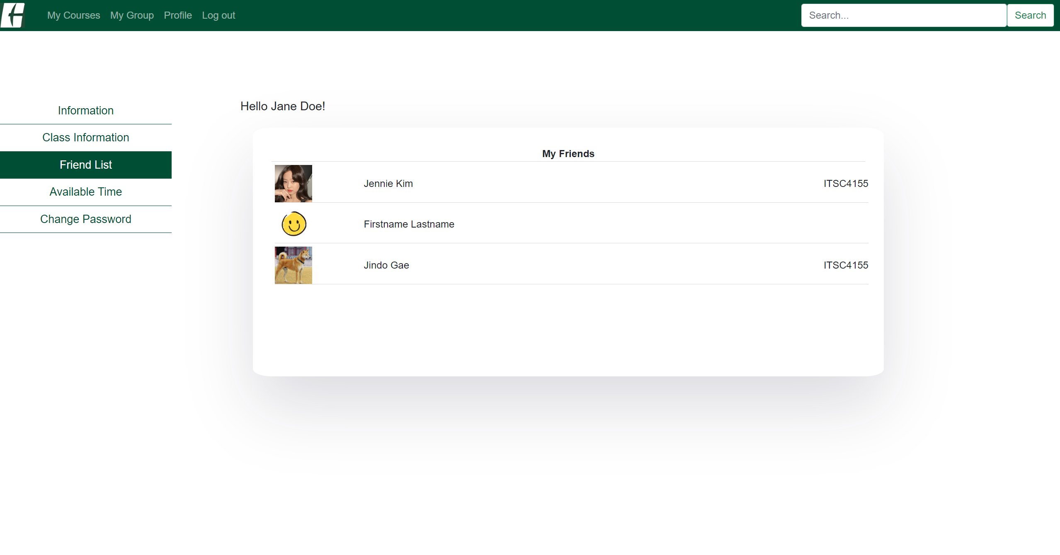

f-2-1. To update the meeting time (available time) and location, you can click Add Time button and Add Location button.

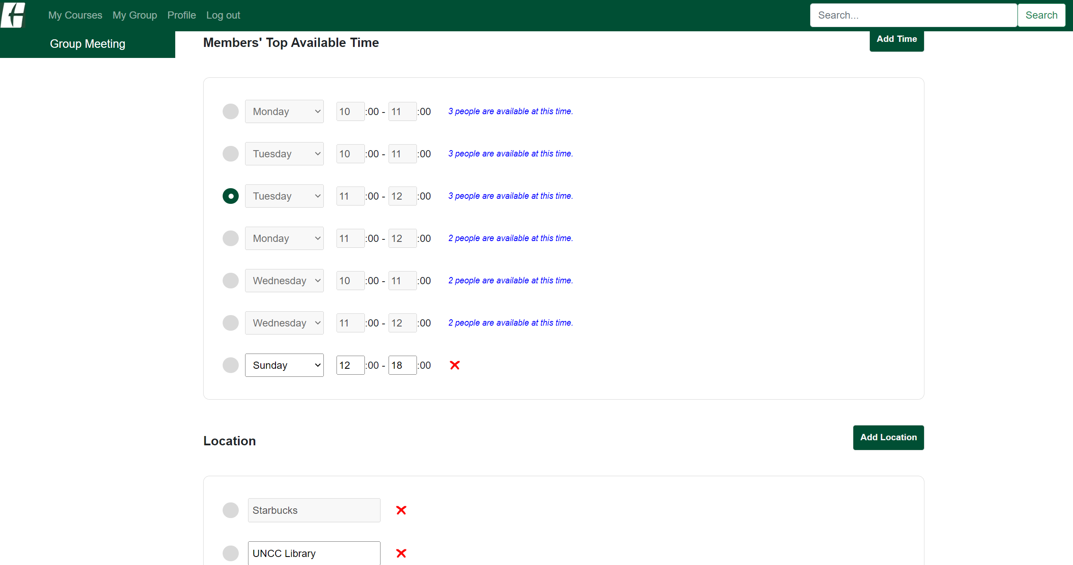

f-2-2. You can click X button to remove the time and location.

*You should refresh your browser once hit the X button.

f-2-3. To save your changes, you can click Save button.

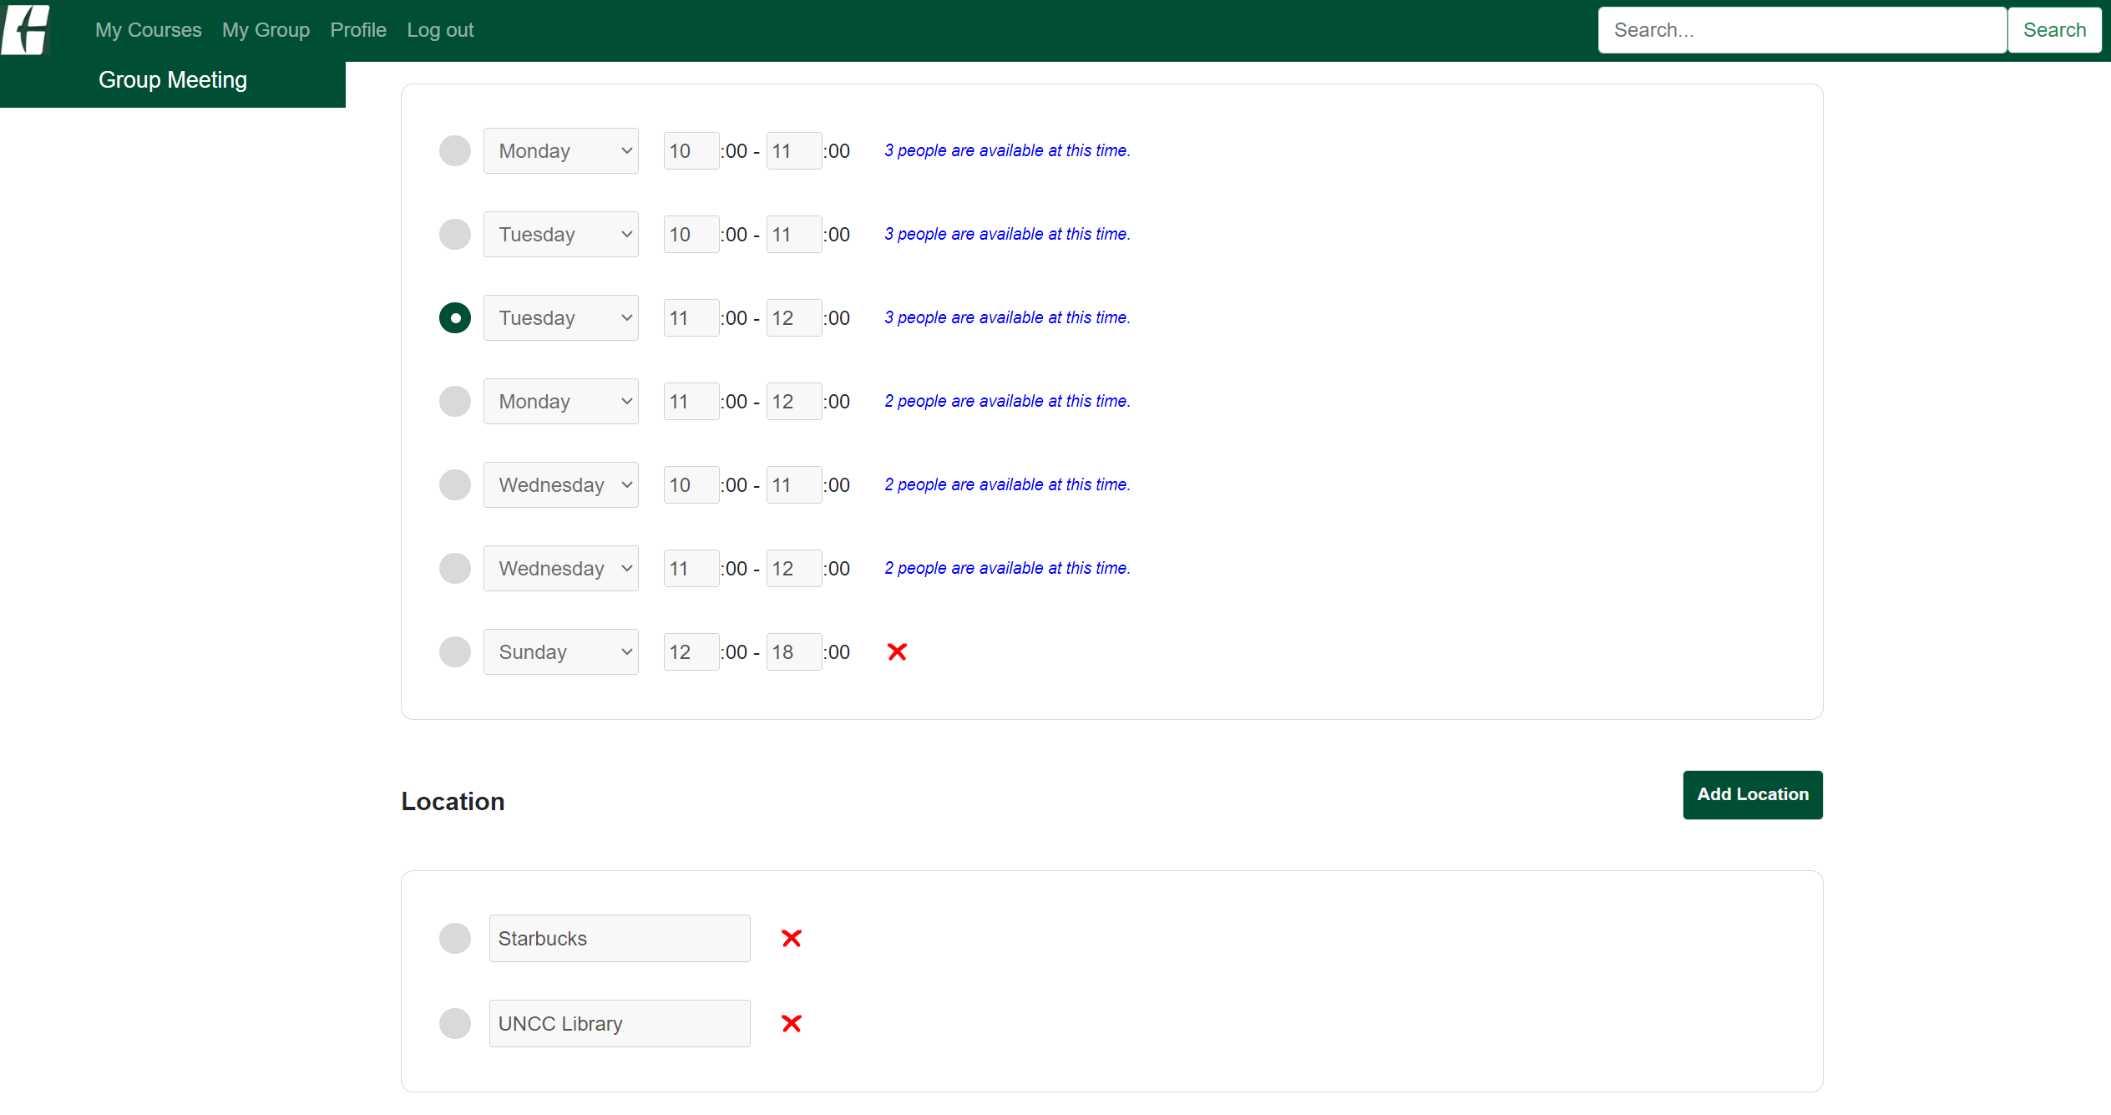

f-2-4. You can choose the meeting time and location by clicking the radio button and hit the Save button. Once you do it, it will be appear in the group information page.

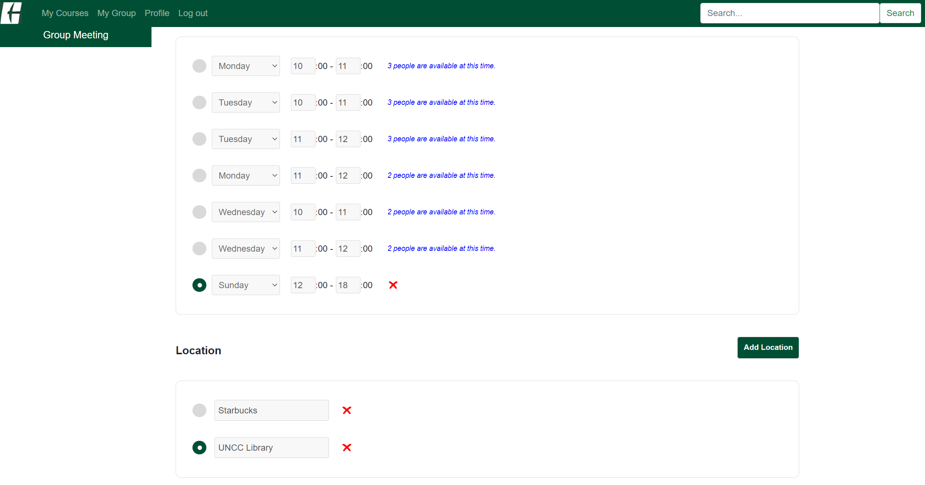

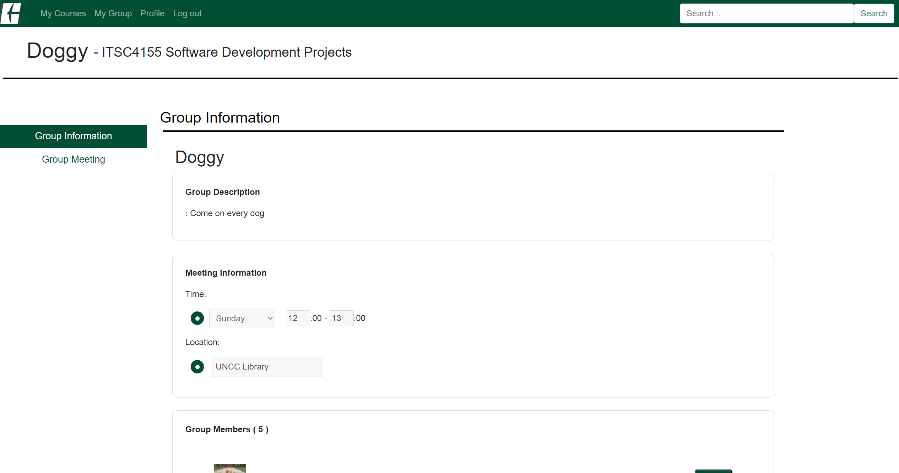

Available time:

Class+ gets each student’s free time as available time in the profile or in the group and shows how many members have free time at the same time.

In the Profile page:

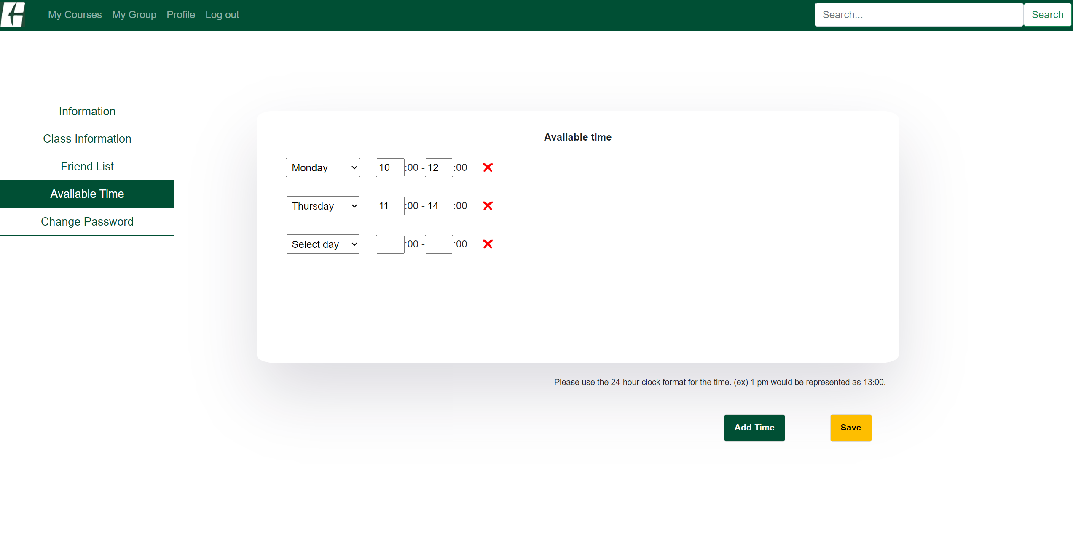

You can set your available time by clicking the Add Time button or X button to remove. Click Save to save your change.

In the Group page:

See Above to see how to add and remove the available time for the group.

In the Group page, it gets the available times from each member’s profile and shows members' top 5 available time.